Computer Vision-based Dental Caries and Disease

Detection from X-ray Images using Machine Learning

January 17, 2024

Contents

1. Introduction 1
   1. Introduction . . . . . . . . . . . . . . . . . . . . . . . . . . . . . . . . . 1
   2. Background Study . . . . . . . . . . . . . . . . . . . . . . . . . . . . . 2
   3. Problem Statement . . . . . . . . . . . . . . . . . . . . . . . . . . . . . 2 1.4 Research Question . . . . . . . . . . . . . . . . . . . . . . . . . . . . . 3

1.5 Objective . . . . . . . . . . . . . . . . . . . . . . . . . . . . . . . . . . 3

1. Literature Review 4
   1. Literature Review . . . . . . . . . . . . . . . . . . . . . . . . . . . . . . 4
   2. Summary of the Related Works . . . . . . . . . . . . . . . . . . . . . . . 5
2. Methods 8
   1. Flowchart . . . . . . . . . . . . . . . . . . . . . . . . . . . . . . . . . . 8
   2. Model and Architecture . . . . . . . . . . . . . . . . . . . . . . . . . . . 9
   3. YOLOv8 . . . . . . . . . . . . . . . . . . . . . . . . . . . . . . . . . . 9
   4. YOLOv5 . . . . . . . . . . . . . . . . . . . . . . . . . . . . . . . . . . 10
   5. Research Environment and Devices . . . . . . . . . . . . . . . . . . . . 11
   6. Environment Setup . . . . . . . . . . . . . . . . . . . . . . . . . . . . . 11
   7. Summary . . . . . . . . . . . . . . . . . . . . . . . . . . . . . . . . . . 11
3. Dataset Description 13
   1. Data-set Description . . . . . . . . . . . . . . . . . . . . . . . . . . . . 13
      1. Dataset Collection . . . . . . . . . . . . . . . . . . . . . . . . . 13 4.1.2 Dataset labeling . . . . . . . . . . . . . . . . . . . . . . . . . . . 13 4.1.3 Data Preprocessing . . . . . . . . . . . . . . . . . . . . . . . . . 14 4.1.4 Image Format and Size . . . . . . . . . . . . . . . . . . . . . . . 14 4.1.5 Data Division . . . . . . . . . . . . . . . . . . . . . . . . . . . . 14 4.1.6 The Preparation Phase . . . . . . . . . . . . . . . . . . . . . . . 14 4.1.7 Augmentations . . . . . . . . . . . . . . . . . . . . . . . . . . . 15

4.1.8 Evaluation Parameters . . . . . . . . . . . . . . . . . . . . . . . 15 4.1.9 Validation Split . . . . . . . . . . . . . . . . . . . . . . . . . . . 15 4.1.10 Model Development and Training . . . . . . . . . . . . . . . . . 15 4.1.11 Model Evaluation . . . . . . . . . . . . . . . . . . . . . . . . . . 15 4.1.12 Model Improvement . . . . . . . . . . . . . . . . . . . . . . . . 16

4.1.13 Quantitative Data Analysis . . . . . . . . . . . . . . . . . . . . . 16

1. Result and Performance Evalutions 17
   1. Results . . . . . . . . . . . . . . . . . . . . . . . . . . . . . . . . . . . . 17
   2. Performance Evaluation . . . . . . . . . . . . . . . . . . . . . . . . . . . 17
2. Web Application 21
   1. Software Development Method . . . . . . . . . . . . . . . . . . . . . . . 21
   2. Deployment . . . . . . . . . . . . . . . . . . . . . . . . . . . . . . . . . 22
   3. Website . . . . . . . . . . . . . . . . . . . . . . . . . . . . . . . . . . . 22
   4. Business Model . . . . . . . . . . . . . . . . . . . . . . . . . . . . . . . 26
   5. Cost Structure . . . . . . . . . . . . . . . . . . . . . . . . . . . . . . . . 28
      1. COCOMO . . . . . . . . . . . . . . . . . . . . . . . . . . . . . 28
   6. Meetings Schedule with Agenda . . . . . . . . . . . . . . . . . . . . . . 31
   7. Contributions . . . . . . . . . . . . . . . . . . . . . . . . . . . . . . . . 31
3. Conclusion 34
   1. Overall Conclusion . . . . . . . . . . . . . . . . . . . . . . . . . . . . . 34
   2. Limitation and Future Works . . . . . . . . . . . . . . . . . . . . . . . . 34

Appendix 37

List of Figures

* 1. Flowchart . . . . . . . . . . . . . . . . . . . . . . . . . . . . . . . . . . 8
  2. Architecture OF YOLOv8 . . . . . . . . . . . . . . . . . . . . . . . . . 10
  3. Architecture of YOLOv5 . . . . . . . . . . . . . . . . . . . . . . . . . . 11

4.1 Stage 1 tooth Decay . . . . . . . . . . . . . . . . . . . . . . . . . . . . . 13 4.2 Stage 2 tooth Decay . . . . . . . . . . . . . . . . . . . . . . . . . . . . . 13 4.3 Stage 3 tooth Decay . . . . . . . . . . . . . . . . . . . . . . . . . . . . . 14

4.4 Carries in the tooth . . . . . . . . . . . . . . . . . . . . . . . . . . . . . 14

5.1 Confusion Matrix of yolov8 . . . . . . . . . . . . . . . . . . . . . . . . 18 5.2 Confusion Matrix of yoloV5 . . . . . . . . . . . . . . . . . . . . . . . . 18

* 1. Confusion Matrix of raw images. . . . . . . . . . . . . . . . . . . . . . . 18
  2. Result of yolov8 . . . . . . . . . . . . . . . . . . . . . . . . . . . . . . . 19 5.5 Result of yolov5 . . . . . . . . . . . . . . . . . . . . . . . . . . . . . . . 19

5.6 Result of yoloV8(Raw) . . . . . . . . . . . . . . . . . . . . . . . . . . . 20

* 1. Home Page . . . . . . . . . . . . . . . . . . . . . . . . . . . . . . . . . 23
  2. X-ray page . . . . . . . . . . . . . . . . . . . . . . . . . . . . . . . . . 23
  3. Output of the x-ray . . . . . . . . . . . . . . . . . . . . . . . . . . . . . 24
  4. Zooming for details . . . . . . . . . . . . . . . . . . . . . . . . . . . . . 24
  5. Raw Image Page . . . . . . . . . . . . . . . . . . . . . . . . . . . . . . 25
  6. Output of the image . . . . . . . . . . . . . . . . . . . . . . . . . . . . . 25
  7. Business Model . . . . . . . . . . . . . . . . . . . . . . . . . . . . . . . 26

Abstract

Computer vision-based dental caries and disease detection from X-ray images using machine learning is a promising area of research for automating and enhancing the accuracy of dental caries diagnosis. Worldwide, dental caries, also known as tooth decay or cavities, is a common problem with oral health. For effective treatment and prevention of further harm, early detection and intervention are essential. An overview of the use of computer vision and machine learning in the detection of dental caries and disease from X-ray images is provided in this abstract. Since dentists’ subjective visual inspections are used in traditional methods of diagnosing dental caries, there is a risk of human error. By providing an objective analysis of X-ray images, computer vision and machine learning algorithms can enhance the diagnostic procedure. The proposed approach involves acquiring X-ray images using dental radiography techniques, followed by preprocessing to enhance image quality and reduce noise. Relevant features are then extracted from the images using techniques such as Yolov8, Yolov5 etc. Machine learning algorithms are trained on a large dataset of annotated X-ray images to learn patterns indicative of dental caries and diseases. The trained model can classify new X-ray images into categories like healthy teeth, dental caries, or specific diseases. Evaluation metrics such as accuracy, precision, recall, and F1 score are used to assess the model’s performance. Additionally, the model can generate heat maps or highlight regions of interest in the X-ray images, aiding dentists in visualization and understanding of areas of concern. Computer vision-based dental caries and disease detection can assist dentists in making accurate diagnoses, leading to timely interventions and improved patient outcomes. It can also enable screening of large populations for dental health issues and reduce the workload of dentists. Challenges include the availability of high-quality annotated data-sets, addressing class imbalance, and ensuring algorithm robustness and generalizability. Computer vision-based dental caries and disease detection using machine learning has the potential to revolutionize dentistry by providing objective analysis of X-ray images. Further research is needed to address challenges and refine techniques for widespread adoption and improved oral healthcare outcomes.

Chapter 1 Introduction

# 1.1 Introduction

Dental caries and other oral diseases is a global health challenge traditionally it is detected through manual inspection and analysis. But manual inspection and analysis is time consuming and costly. Our research explores the way for detecting dental diseases from X-ray images through machine learning and computer vision techniques. Despite being a nascent field, the fusion of machine learning and computer vision in dental imaging has shown promise in automating the detection process, reducing human error, and potentially improving diagnostic accuracy [8]. But this field also faces challenges related to data availability and quality, model interpretability, and integration into clinical workflows. Artificial intelligence into dental imaging introduces a new era in dental healthcare, where diagnostic accuracy and consistency are significantly improved[13].

Traditionally, dental caries detection has been heavily dependent on radiographic imaging, such as X-ray imaging, which provides detailed information about the internal structure of teeth. However, the manual interpretation of X-ray images is subjective and can be prone to human errors, leading to potential misdiagnosis or delayed treatment[9]. Moreover, the increasing workload on dental professionals motivated us to develop automated systems that can assist in the early detection and diagnosis of dental caries.

Computer vision-based approaches, coupled with machine learning algorithms, have come up as a promising solution to automate the process of dental caries detection from X-ray images[10]. By leveraging the power of deep learning models, these techniques can analyze large volumes of dental X-rays with exceptional precision, speed, and consistency, assisting dental professionals in making accurate diagnoses.

As the foundation for training of deep learning models, such as convolutional neural networks (CNNs) we made a dataset of annotated dental X-ray images, which includes various stages of dental caries and oral diseases. The models will be trained to automatically extract meaningful features from X-ray images, enabling them to classify and localize dental caries accurately.

Actually this research tries to create an automated system for dental caries and disease detection from X-ray images by computer vision and machine learning techniques. The outcomes of this study have the potential to significantly improve the accuracy and efficiency of dental diagnosis.

# 1.2 Background Study

Worldwide, dental caries, also known as tooth decay or cavities, is a common problem with oral health. But the detection and diagnosis of dental caries have not kept pace with the advancements in artificial intelligence and machine learning.Traditional methods of dental caries detection primarily rely on x-ray images and inspection by dentists. These traditional methods are sensitive to human error and inconsistency since they are subjective and heavily rely on the knowledge and experience of the dentist. Additionally, the procedure takes a long time, and early-stage caries might occasionally go unnoticed or be misdiagnosed. So an automated dental caries detection system is necessary in the modern day, where artificial intelligence and machine learning play a vital role in many fields.

By leveraging the capabilities of artificial intelligence and machine learning, an automated dental caries detection system can revolutionize the way dental caries are diagnosed. Computer vision techniques can be used to analyze dental X-ray images, such as bitewing radiographs, and extract relevant information. Machine learning algorithms can then be trained on large datasets of annotated X-ray images to learn patterns and features associated with dental caries.

The benefits of an automated dental caries detection system are many. Firstly, it can enable early detection of dental caries, allowing for timely intervention and treatment. Early intervention can prevent the progression of caries, potentially saving patients from more extensive and expensive dental procedures in the future. Secondly, the system can improve the accuracy of diagnoses by reducing human error and subjectivity. Consistent and objective analysis of X-ray images can lead to more reliable diagnoses and treatment plans. That’s the reason we chose this topic where we are working on making an automated dental caries detection system.

# 1.3 Problem Statement

This project addresses the need for an efficient and accurate system for detecting and diagnosing dental caries and illnesses utilizing X-ray pictures via a computer vision-based approach. Traditional dental diagnostic methods might be time-consuming and inaccurate. The merging of machine learning algorithms with computer vision techniques presents a viable option to improve the speed and accuracy of oral health assessments as technology advances.

The manual and subjective character of old diagnostic methods contributes to the risk of human error and variances in interpretation. Furthermore, early detection of oral problems is essential for effective intervention and treatment. As a result, the project intends to create a robust system that analyzes X-ray pictures and provides automated, reliable, and speedy identification of dental caries and illnesses using machine learning techniques. The suggested method aims to increase diagnostic accuracy, reduce reliance on human interpretation, and promote early intervention, resulting in improved dental healthcare outcomes.

# 1.4 Research Question

The existing solutions could not define the How much is teeth decayed. Those solutions are only focused on dental caries. Hence all those issues leads to the following Research Questions ( RQ ):

RQ 1. What are the different computer vision and machine learning techniques that can be used to detect dental caries and diseases?

RQ 2. What are the advantages and disadvantages of each computer vision and machine learning technique?

RQ 3. What is the accuracy of each computer vision and machine learning technique for detecting dental caries and diseases?

RQ 4. How can the accuracy of computer vision and machine learning techniques for detecting dental caries and diseases be improved?

RQ 5. How can computer vision and machine learning techniques for detecting dental caries and diseases be made more affordable and accessible?

# 1.5 Objective

The objective of the research is to present our plan for creating a system that will contribute to identify individuals with dental issues using Deep Learning.

1. This objective aims to assess the accuracy and efficiency of AI-based methods compared to traditional human interpretation. Artificial intelligence (AI) in dental caries detection using panoramic dental X-ray images.
2. Examine dental caries using panoramic dental X-ray pictures to determine its severity and progression such as examine the size and seriousness of dental caries lesions shown in panoramic X-rays.
3. To investigate the role of artificial intelligence (AI) in dental caries detection using panoramic dental X-ray images the role of artificial intelligence (AI) in dental caries detection using evaluate their feasibility and performance to the given clinical quality evaluation problem.
4. To figure out which attribute is the most valuable in distinguishing individuals with dental issues.
5. To find a link between caries state and the necessity for restorative therapies, endodontic therapy, or tooth extraction.

Chapter 2 Literature Review

# 2.1 Literature Review

Dental caries are common chronic infectious oral diseases affecting most teenagers and adults worldwide[4]. Data from the National Health and Nutrition Examination Survey reveals that dental caries affect 41 of US children aged 2–11 years (in their primary teeth), 42% of children and adolescents aged 6–19 years, and nearly 90% of adults aged 20 years or older (in their permanent teeth) [2][3]. Like other medical fields, in dental the demand for automated medical assistance systems is increasing day by day because of progressive research in the field of machine learning [16]. However, there has not yet been a significant improvement in the diagnostic methodology for detecting dental caries due to various anatomical morphologies of teeth and the shapes of restorations[6]. This paper proposes an automated dental diseases treatment quality evaluation procedure using dental radiograph image classification. The system integrates medical experts’ experience, image processing algorithms, and convolutional neural network-based learning. It uses 196 pair-wised periapical dental X-ray images and unifies them using image registration processes, focusing on ROIs rather than pixel differences. The results show an overall F1-score of 0.749, comparable to expert-level dental practitioners [22].

Deep learning methods have shown impressive diagnostic performance in radiology, with a study comparing their performance with expert dentists. The study used 1160 dental panoramic films and trained nnU-Net and DenseNet121 models [9]. Results showed no significant differences in accuracy, precision, recall, NPV, and F1-score metrics between the trained and expert dentists [9]. Radiographic images are crucial in dentistry for diagnosing and treating dental problems, enabling early detection and treatment planning. They also aid in forensic identification, assessing age and identifying individuals based on dental characteristics. Advancements in artificial intelligence and pattern recognition algorithms further enhance their use [20]. Caries detection in various studies was evaluated, with three defining caries as radiolucent areas, seven detailing types, six not specifying, and eight evaluating accuracy from 68.57% to 99% [15]. A U-shaped deep CNN model was developed for early dental caries detection in bitewing radiographs, achieving diagnostic performance of 63.29% position, 65.02% recall, 64.14% f1 score, and sensitivity of 95% [7].

# 2.2 Summary of the Related Works

Table 2.1: Summary of the Related Works

|  |  |  |
| --- | --- | --- |
| Title | Worked On | Results |
| Classification of Dental Diseases using CNN and  Transfer Learning. | Classification of three major dental diseases Dental Caries, Periapical Infection, Periodontitis using Convolutional Neural Networks (CNNs) & transfer learning. | Accuracy according to models, CNN- 0.7307.  Transfer learning- 0.8846 transfer learning with fine tuning- 0.8846. |
| Cephalometric landmark detection in dental X-ray Images using convolutional neural networks. | Landmark detection system for dental image analysis by constructing multiple CNN-based regression systems predicting individual coordinate values of landmarks, independently. | Showed promising potential but had limitations in terms detection accuracy. The detected landmarks were not perfectly matched with the ground truths but were reasonably located within certain margins. The study identified scaling issues and the lack of deep learning techniques as contributing factors to the accuracy limitations. To improve accuracy. |
| Detection and diagnosis of dental caries using a deep learning-based convolutional neural network algorithm. | Evaluate the efficacy of deep CNN algorithms for detection and diagnosis of dental caries on periapical radiographs. | The deep CNN algorithm achieved an AUC of 0.917 on premolar, an AUC of 0.890 on molar, and an AUC of 0.845 on both premolar and molar models. The premolar model provided the best AUC, which was significantly greater than those for other models  (P < 0.001) |
| Deep Learning for Caries Detection and Classification. | Comprehensive and early detection of dental caries. | There are 1160 dental panoramic films which were used in this paper. After reading this paper the model accuracy was 0.986 sensitivity 0.821 specificity 1 precision is 1 and lastly the F1 score is  0.902. |
| Title | Worked On | Results |
| Automated Dental Image Analysis by Deep Learning on Small Dataset. | Evaluate dental treatment qualities using periapical dental X-ray images taken before and after the operations. In order to support dentists to make clinical decisions. | The result of this paper is about the patient who had an operation from a dental disease. There are a data set where we can say 196 patient. There are three classes in this image processing One is getting better another one is no change lastly getting worse. The aggregated result of this model precision is 0.537 recall is 0.490 and F1 score is 0.517. The highest iPhone score is seen in getting better cases and lowest in the getting worst cases. |
| Dental Caries Diagnosis and Detection Using Neural Networks: A Systematic Review. | This systematic review aims to identify the state of the art of neural networks in caries detection and diagnosis. | Several studies focused on caries detection. Three studies provided a definition of caries as a radiolucent area on a structure. Seven studies detailed the types of caries detected, including occlusal, proximal, enamel, dentinal lesions, pre-cavitated lesions, and initial caries. Six studies did not specify the types of caries detected. Seven studies did not mention the specific teeth affected, while four studies focused on molar and premolar teeth, and two studies used posterior extracted teeth. Eight studies evaluated accuracy, with results ranging from 68.57 % to 99% . |
| Title | Worked On | Results |
| Deep learning for early dental caries detection in bitewing radiographs. | Developed a CNN model using a U-shaped deep CNN (U-Net) for caries detection on bitewing radiographs and investigated whether this model can improve clinicians’ performance. | The diagnostic performance of the final CNN model on the total data set was position 63.29 % recall 65.02% and f1 score 64.14%. And the overall sensitivity of this model was 95% PPV is 95% and F1 score is 95% . |
| Automatic segmenting teeth in X-ray images: Trends, a novel data set, benchmarking and future perspectives. | In-depth study on segmentation methods in literature that regarded to the recognition of image patterns in dental x-rays. | These paper shows that the niblack method reach the highest value of the recall matric approximately 83% indicate that indicates the segmented image presented the highest number of true positive and few false negative in the comparison. Another method is marker control watershed which also obtain 80% of recall metric. The active contour without ages and the level sets segmentation method obtain less than 70% of the recall metric. Stating that the segmentation process of panoramic extra images of the teeth based on thresholding, achieved significant performance improvement when a local threshold (niblack method) was used, instead of using basic global threshold. |

Chapter 3

Methods

Traditional image processing techniques, machine learning with custom features, and deep learning utilizing Convolutional neural networks(CNNs), more commonly can all be used to diagnose dental caries and other diseases from X-ray pictures.

# 3.1 Flowchart

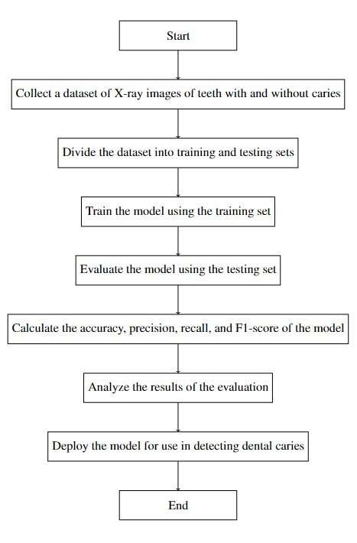

Figure 3.1: Flowchart

The flowchart shows how the project will work from starting to end. At first we have to collect a data set. The data set will be a bunch of x-rays images of teeth and raw images. The x-rays and raw tooth images will be with and without carries. Then we have to preprocess the data set according to the x-rays and raw images. we can add technologies to identify proper images while pre-processing the images. After formatting the images, we have to divide the data set. The splitting of the data set will be training set validation set and testing sets. After splitting the data set we have to train the model using training set. After training the training set we have to evaluate the model. We can evaluate the model using testing set. Then we have to make sure the accuracy, precision, recall and F-1 score is good for the model. Otherwise we have to reevaluate the model. Then we have to analyze the model’s evaluation. Finally, we can run the model for deployment in the website for detecting dental carries.

# 3.2 Model and Architecture

The proposed model for this project is a convolutional neural network (CNN). CNNs are a sort of machine learning model that is created primarily for image identification jobs. They can learn the spatial relationships between pixels in an image, making them ideal for detecting minute, subtle changes in images, such as those seen in early-stage dental caries. The CNN that will be utilized in this study will be trained using a data-set of Xray images of teeth with and without caries. The data-set will be divided into two parts: training and testing. The training set will be used to train the CNN, and the test set will be used to assess its performance. A supervised learning strategy will be used to train the CNN.

That is, I will provide CNN the ground truth labels for the photos in the training set. The ground truth labels will indicate whether or not each image has caries. The PyTorch framework will be used to implement the CNN. PyTorch is an open-source machine learning framework optimized for deep learning. It’s commonly utilized by computer vision researchers and developers. The CNN will be assessed using a number of measures, including accuracy, precision, recall, and F1-score. These indicators will be utilized to provide a more comprehensive picture of CNN’s performance. The CNN will be trained using a supervised learning technique. In other words, I will give CNN the ground truth labels for the photographs in the training set. Each image’s ground truth labels will indicate whether or not it contains caries. The CNN will be implemented using the PyTorch framework. PyTorch is an open-source deep learning machine learning framework. It is frequently used by computer vision researchers and engineers. A number of metrics will be used to evaluate the CNN, including accuracy, precision, recall, and F1-score. These metrics will be used to present a more complete view of CNN’s performance. The models we used for our project are yolov8, Yolov5.

# 3.3 YOLOv8

It’s a new state-of-the-art in computer vision, supporting object detection, classification, and segmentation tasks. As we use segmentation, we use this model for our project. It’s also from the YOLO family. YOLOv8 exhibits impressive accuracy, as demonstrated by high scores on COCO and Roboflow 100 evaluations.

It offers a range of developer-friendly features, including an accessible CLI and a wellorganized Python package. The model benefits from a thriving community of computer vision enthusiasts, ensuring a strong support network. For instance, the YOLOv8m (medium) model achieves a significant 50.2% map on COCO, indicating robust performance. In head-to-head comparisons, YOLOv8 outperforms YOLOv5 on the taskspecific Roboflow 100 dataset, as detailed in our performance analysis later in this article.

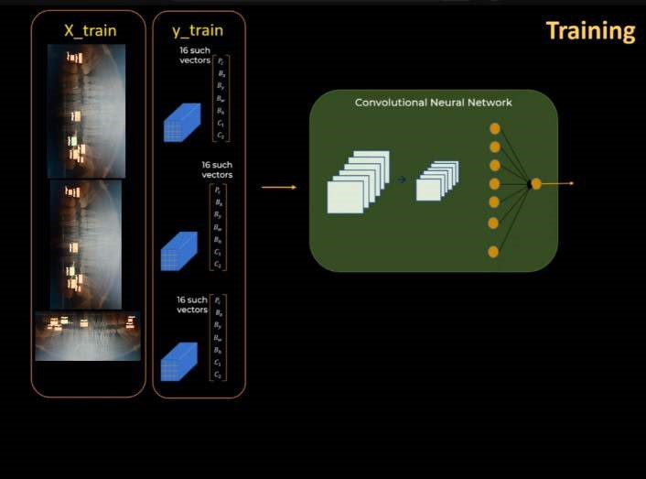

Figure 3.2: Architecture OF YOLOv8

# 3.4 YOLOv5

YOLOv5 is a model in the You Only Look Once (YOLO) family of computer vision models. YOLOv5 is commonly used for detecting objects.The YOLOv5 architecture is centered around efficient and accurate real-time object detection. It employs the CSPDarknet53 backbone, featuring the CSP module for improved information flow between network stages. The PANet neck refines features by aggregating information across different paths, enhancing spatial hierarchies and context representation. The detection head processes refined features, predicting bounding boxes with class probabilities at various scales and aspect ratios. Anchor boxes aid in accurate localization by adjusting predefined bounding box sizes during training. The model employs a combination of regression and classification losses during training. Post-processing involves non-maximum suppression to filter out redundant bounding boxes, ensuring only the most confident detections are retained. Overall, YOLOv5 is designed for efficiency, leveraging a well-structured architecture to achieve robust and real-time object detection performance.

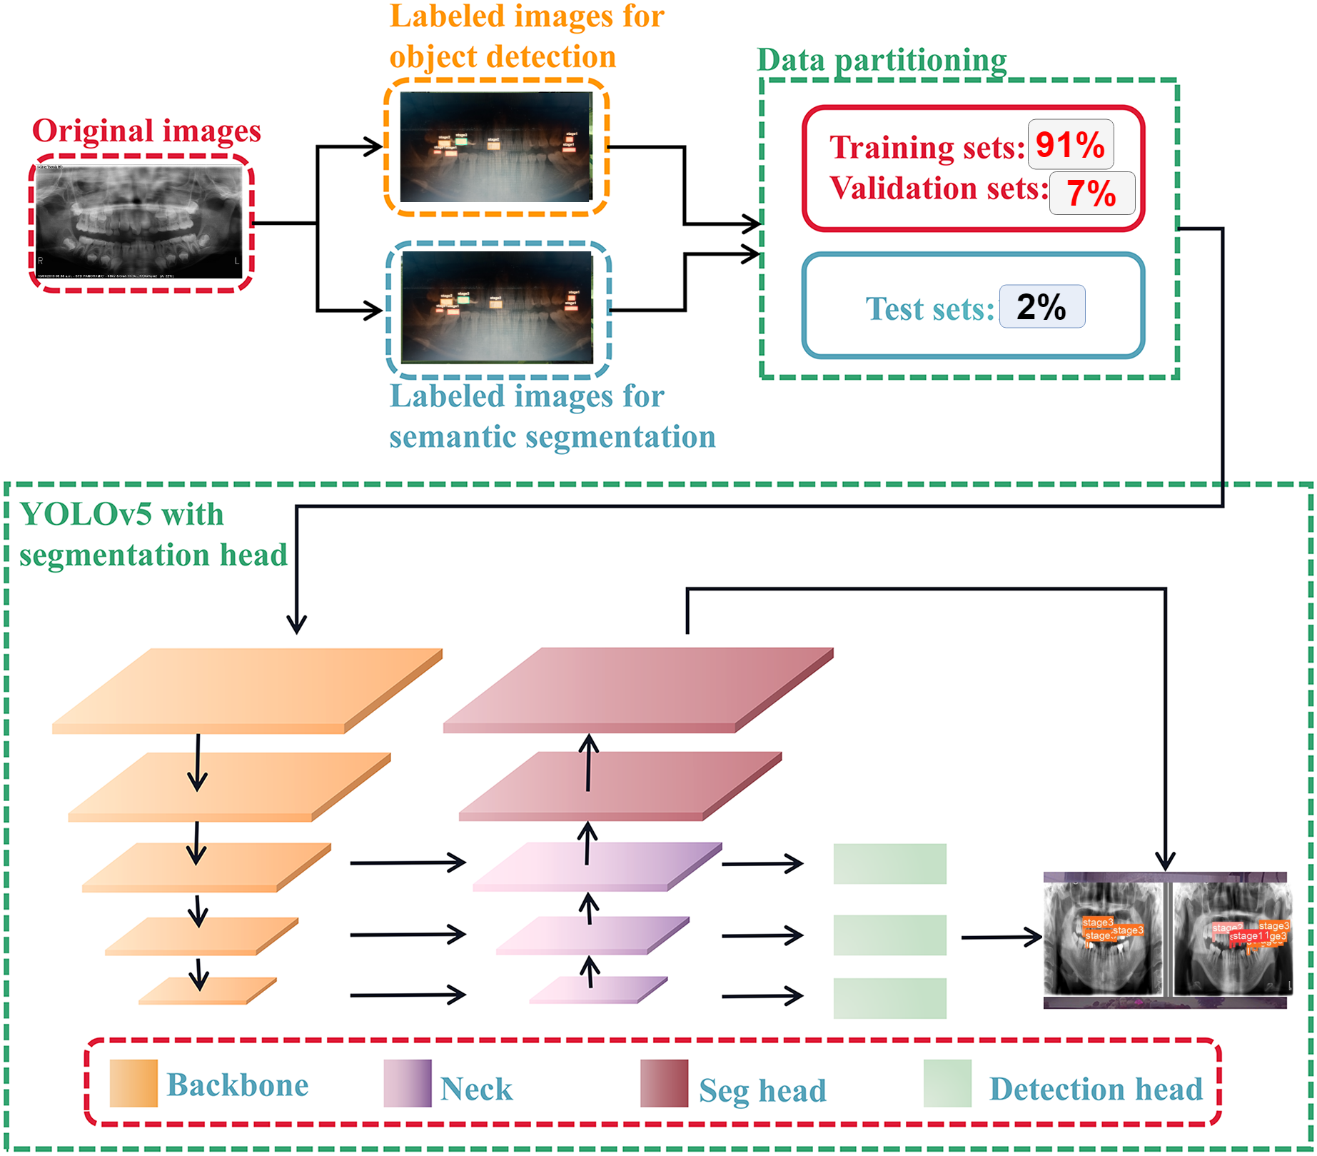

Figure 3.3: Architecture of YOLOv5

# 3.5 Research Environment and Devices

The proposed system was built on Colab Notebook, a computing platform, Models were built using TensorFlow deep learning frameworks.

# 3.6 Environment Setup

We have collected the raw data from the field. At the same time, a common way to change the results of image training is a random form of distortion, cropping, or sharpening the training input, which has the advantage of extending the effective size of the training data, thanks to all possible changes in the same image. And it tends to help network learning to deal with all distortion problems that will occur in the real use of classifiers. Therefore, when the training results are abnormal, the images will be deformed randomly to avoid the large interference caused by individual abnormal images to the whole model. We have used and checked Multiple proposed system was built on Colab Notebook, a computing platform, Models were built using TensorFlow deep learning frameworks.

# 3.7 Summary

This research initiative focuses on advancing dental diagnostics through a computer visionbased approach for the detection and classification of dental caries and diseases in Xray images. Employing state-of-the-art deep learning architectures, specifically YOLOv8 models, the study aims to enhance segmentation precision guided by dataset characteristics and available computational resources.

The project explores ensemble strategies and attention mechanisms to optimize disease detection accuracy. The ultimate goal is to develop a sophisticated model that facilitates improved diagnosis for dental professionals. The dataset encompasses diverse X-ray images, each representing different dental conditions, with the system designed to precisely locate and visually display detected issues on a screen.

The comprehensive methodology covers dataset collection, tailored pre-processing techniques, model construction utilizing YOLOv8, performance evaluation metrics, and the integration of machine learning for heart failure detection. This integrated approach seeks to contribute significantly to the evolution of dental diagnostics, offering a robust and effective system for detecting dental caries and diseases.

Chapter 4 Dataset Description

# 4.1 Data-set Description

## 4.1.1 Dataset Collection

The data-set for this study will consist of X-ray images of teeth with and without caries. The data will be gathered from many sources, including dentistry clinics, hospitals, and kaggle. The presence or absence of caries will be annotated on the photos in the dataset. We collect almost 700 images but we can use only 454 images from them as other images are not relevant to our project so we don’t use them. On the other hand we have collected 300 teeth pictures from kaggle. From those we were able to use 261 pictures for annotation.

## 4.1.2 Dataset labeling

Dentists or dental hygienists will offer the labels. Here we consider three stages of carries. In an X-ray image we label them as stage 1, stage 2 and Stage 3 each carefully with the help of a dentist. We have also collected raw tooth images and leveled them.

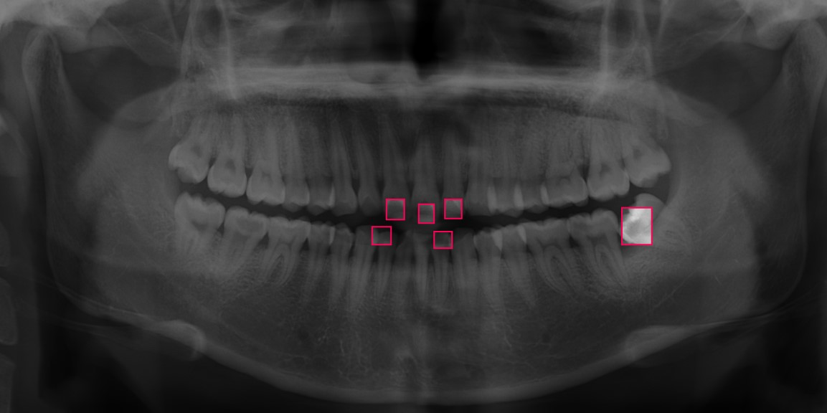

Figure 4.1: Stage 1 tooth Decay

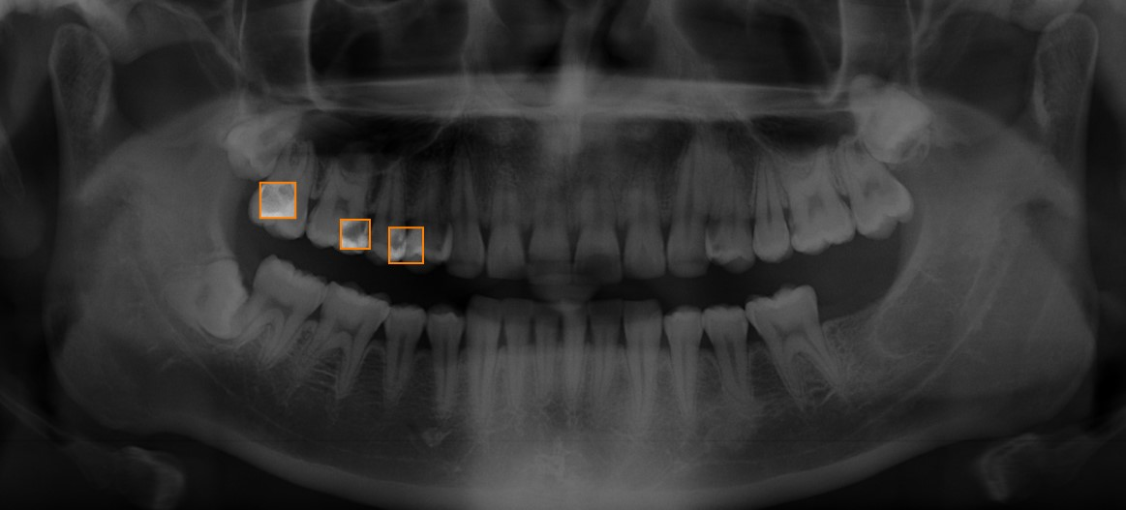

Figure 4.2: Stage 2 tooth Decay

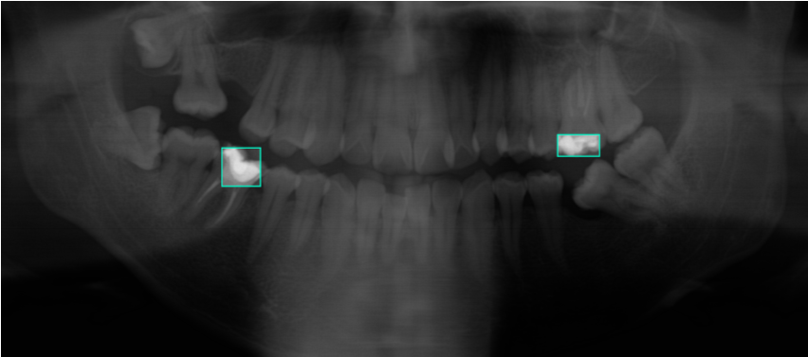

Figure 4.3: Stage 3 tooth Decay

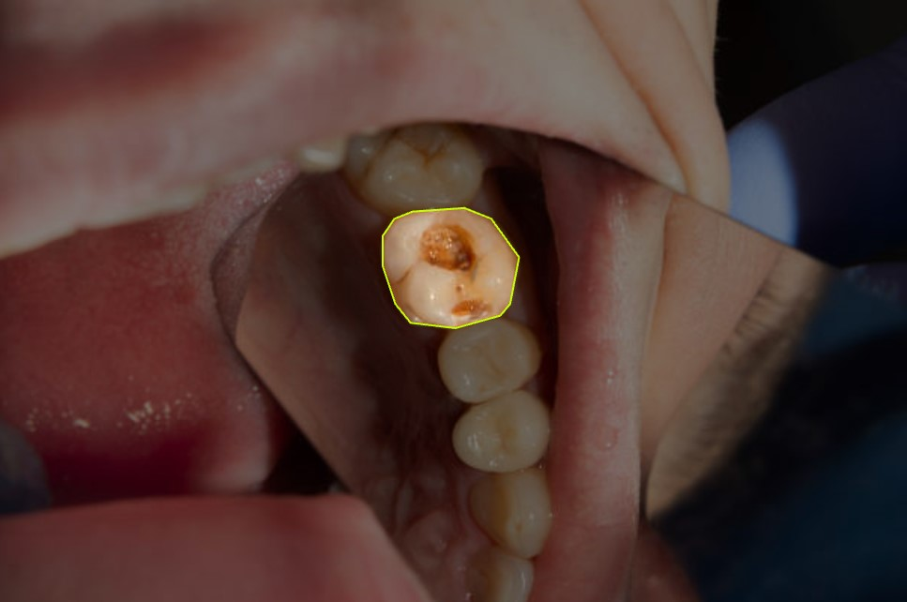

Figure 4.4: Carries in the tooth

## 4.1.3 Data Preprocessing

We have 454 images and 261 raw tooth images that we preprocess them using state of the art technology like roboflow.

## 4.1.4 Image Format and Size

* The dataset’s photos are of the same size, measuring 640 * 640.
* The photographs come in a specified format (JPG), which makes it simple to edit them using tools for common image processing.

## 4.1.5 Data Division

* A training set, validation set, and test set might be created from the dataset.
* The data set split is 91% teaching, 7% validation, and 2% testing.

## 4.1.6 The Preparation Phase

* Before training the model, preprocessing methods including picture scaling, normalization, and augmentation are used.
* These preprocessing techniques improve the model’s capacity to learn pertinent features by ensuring consistent input dimensions.

## 4.1.7 Augmentations

* Flip: Horizontal, Vertical
* Rotation: Between -15° and +15 °
* Shear: ±15° Horizontal, ±10° Vertical
* Bounding Box: 90° Rotate: Clockwise, Counter-Clockwise, Upside Down
* Bounding Box: Rotation: Between -15° and +15 °

## 4.1.8 Evaluation Parameters

* Evaluation criteria that may be used to gauge the effectiveness of the disease classification model include accuracy, precision, recall, and F1-score.
* To get insight into the model’s predictions for each carries class, a classification report and confusion matrix may be prepared.

## 4.1.9 Validation Split

* The ‘validation split‘ parameter is set to 0.7 in the ‘ImageDataGenerator‘.
* It splits the dataset into training and validation subsets, with 91% of the data used for training and 7% for validation.
* The validation split helps assess the model’s performance on unseen data and prevent overfitting.

Overall, the combination of these data augmentation techniques enhances the dataset by generating additional variations of the original images, thereby improving the model’s ability to generalize and classify tomato leaf diseases accurately.

## 4.1.10 Model Development and Training

* Create a Yolov8, Yolov5 and U net architecture suitable for detecting dental cavities and disease.
* Train those models with the training set and tune the hyper parameters with the validation set.
* Evaluate the model’s performance using several measures including accuracy, precision, recall, F1 score.

## 4.1.11 Model Evaluation

* Assess the trained model’s performance on the test set to determine its accuracy in detecting dental caries and disease.
* Analyze and analyze the evaluation metrics to determine the model’s effectiveness.

## 4.1.12 Model Improvement

* Look at ways to improve the model’s accuracy in detecting dental caries and disease.
* Investigate strategies such as data augmentation, transfer learning, and architectural changes to improve the model’s performance.

## 4.1.13 Quantitative Data Analysis

* Use statistical analytic tools to statistically evaluate the model’s performance.
* To assess the model’s effectiveness, compute and present measures such as accuracy, precision, recall, F1 score, and area under the ROC curve.

Compile a broad dataset of dental X-ray images, comprising various types of dental caries and illnesses, with appropriate annotations. Collaborate with dental professionals to ensure the quality and relevance of the dataset to real-world circumstances.

Chapter 5

Result and Performance Evalutions

# 5.1 Results

|  |  |  |  |  |  |
| --- | --- | --- | --- | --- | --- |
| Serial No | Model Name | Avg. P(%) | Avg. R(%) | Avg. F1 score(%) | Accuracy ( % ) |

|  |  |  |  |  |  |
| --- | --- | --- | --- | --- | --- |
| 1 | YoloV8 | 73.17% | 38.96% | 50.71% | 74.45 % |
| 2 | YoloV5 | 61.33% | 28.53% | 27.10% | 66.7 % |
| 3 | YoloV8(Raw) | 64.93% | 96.15% | 77.51% | 71.56 % |

Table 5.1: Each model’s Accuracy, Precision, Recall, F1-Score.

The models evaluated include a YoloV8, YoloV5. The evaluation metrics used are average precision (P), average recall (R), average F1-score, test loss, and test accuracy.

* Precision: YoloV8 has a higher average precision (73.17%) compared to YoloV5 (61.33%), indicating that YoloV8 is better at avoiding false positives.
* Recall: YoloV8 also has a higher average recall (38.96%) compared to YoloV5 (28.53%), suggesting that YoloV8 is better at capturing true positives.
* F1 Score: YoloV8 has a higher average F1 score (50.71%) compared to YoloV5 (27.10%), which is a balanced metric considering both precision and recall.
* Accuracy: YoloV8 has a higher overall accuracy (74.45%) compared to YoloV5 (66.7%), indicating that it performs better in correctly classifying objects.

In summary, based on these metrics, YoloV8 outperforms YoloV5 in terms of precision, recall, F1 score, and overall accuracy. This suggests that YoloV8 is a more effective model for object detection and classification tasks compared to YoloV5 in the evaluated context.

# 5.2 Performance Evaluation

## Confusion Matrix

Confusion matrices use real labels and predicted values to evaluate models’ performance.

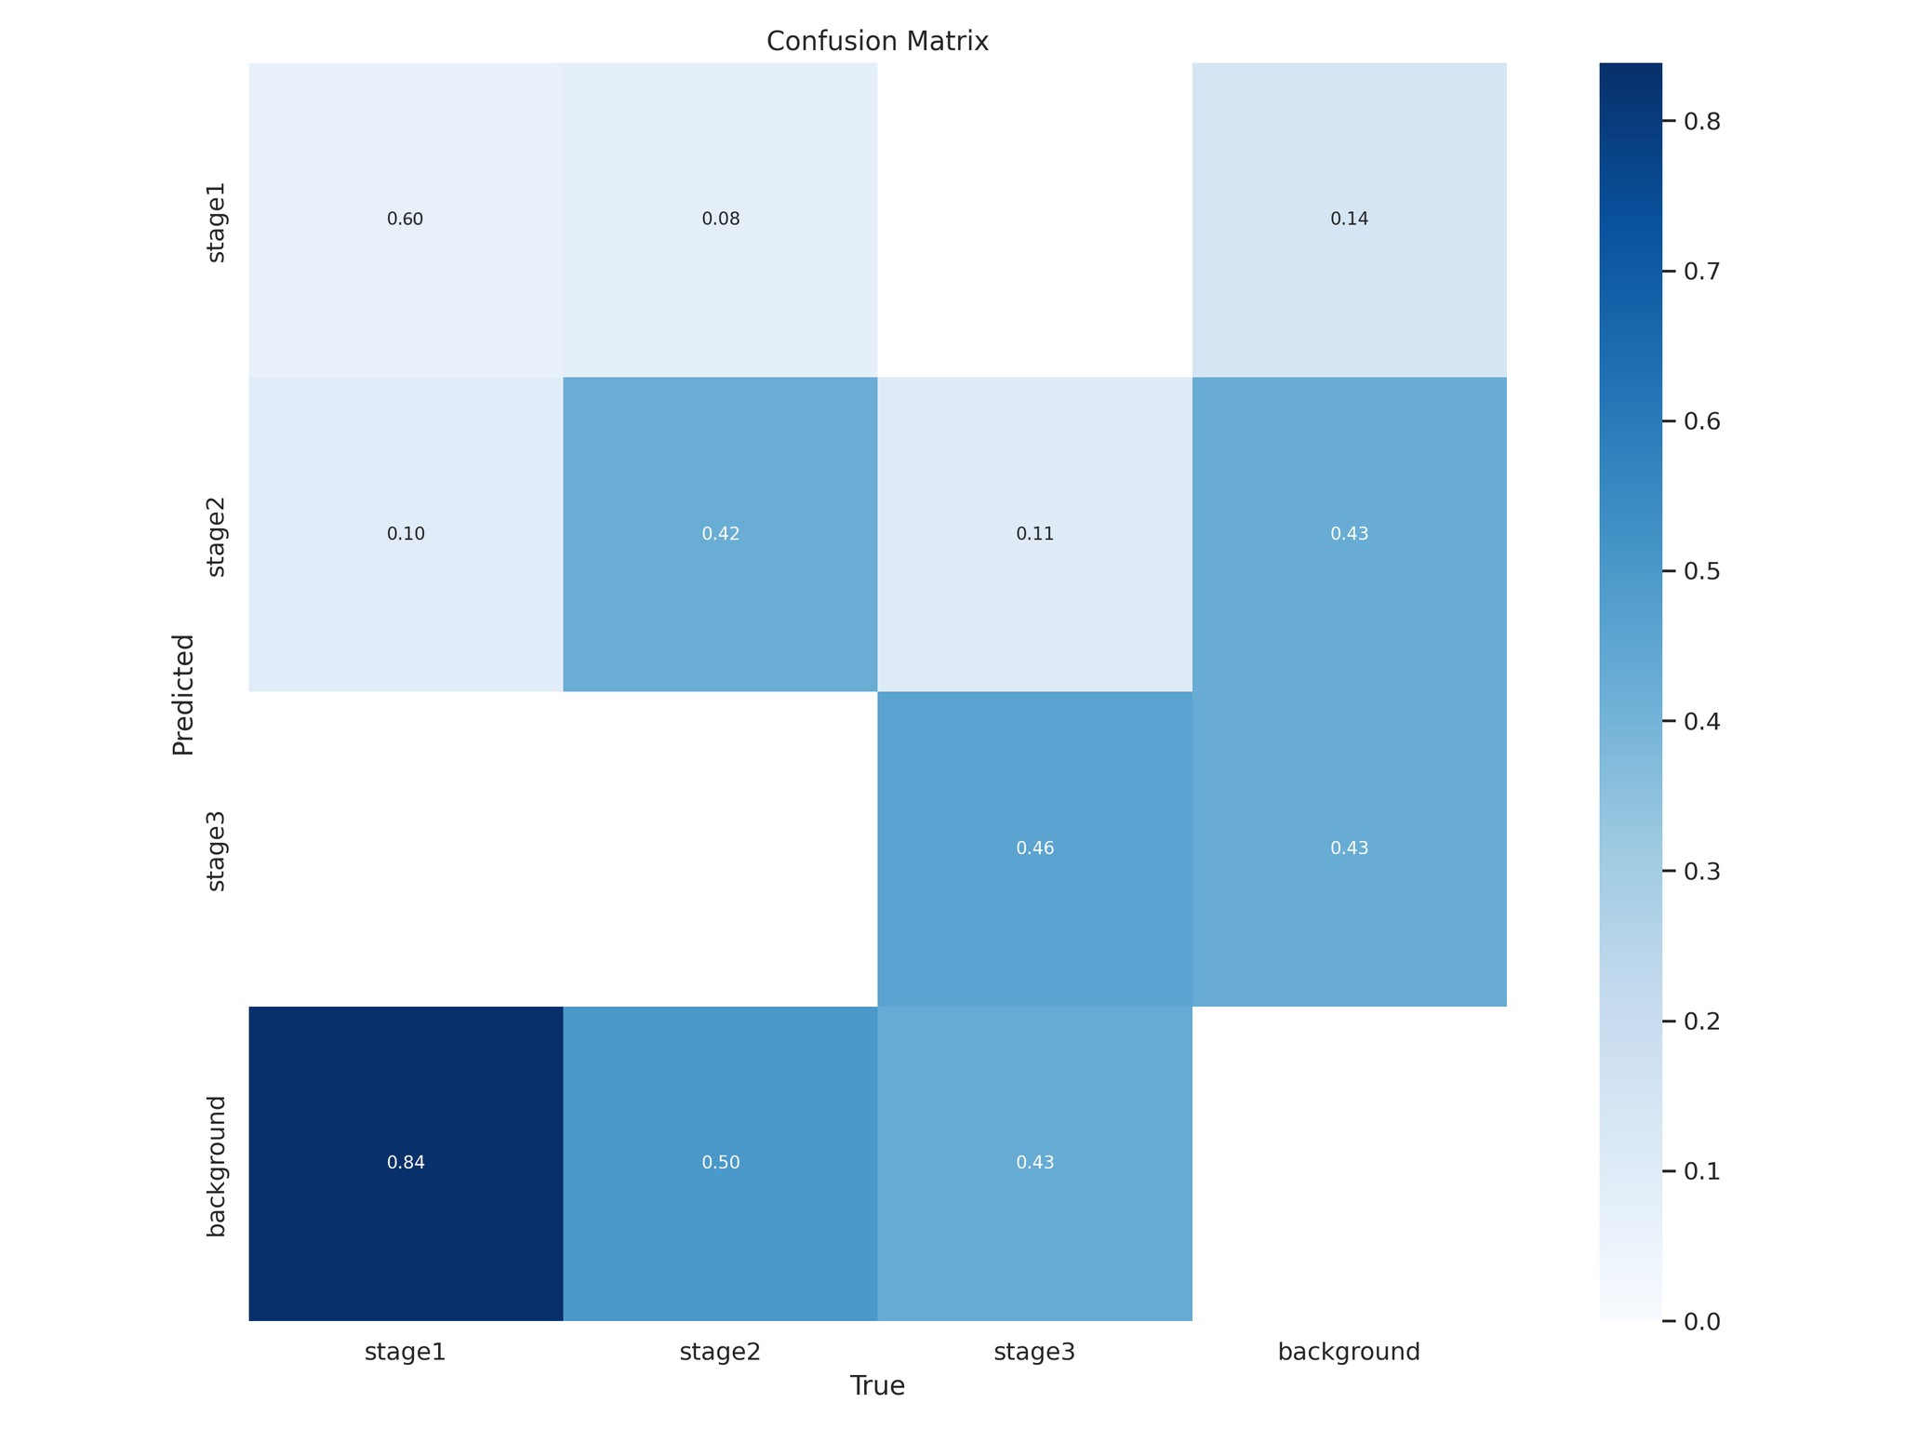

Figure 5.1: Confusion Matrix of yolov8

The Following Confusion Matrix is 4*4. There are four classes. One is Stage1, Stage2, Stage3 another one is Background. We can say Background is no carries class. So here is the following confusion matrix described: TP (True Positive) is diagonal in this matrix. So TP= 60, 42, 46 and 0.

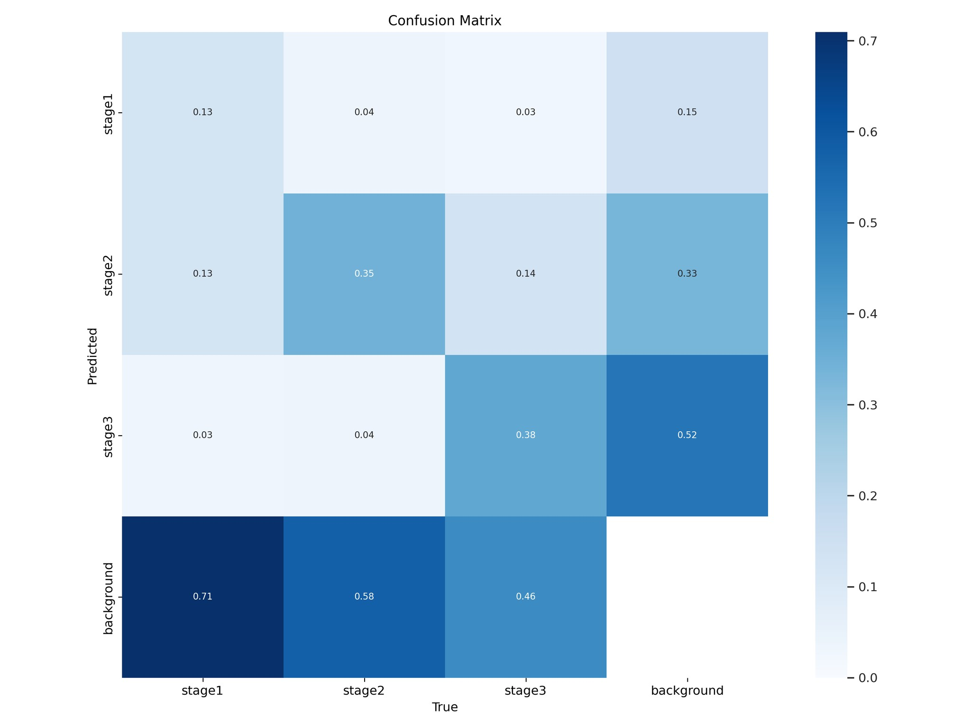

Figure 5.2: Confusion Matrix of yoloV5

The Following Confusion Matrix is 4*4. There are four classes. One is Stage1, Stage2, Stage3 another one is Background. We can say Background is no carries class. So here is the following confusion matrix described: TP (True Positive) is diagonal in this matrix. So TP= 13, 35, 38 and 0.

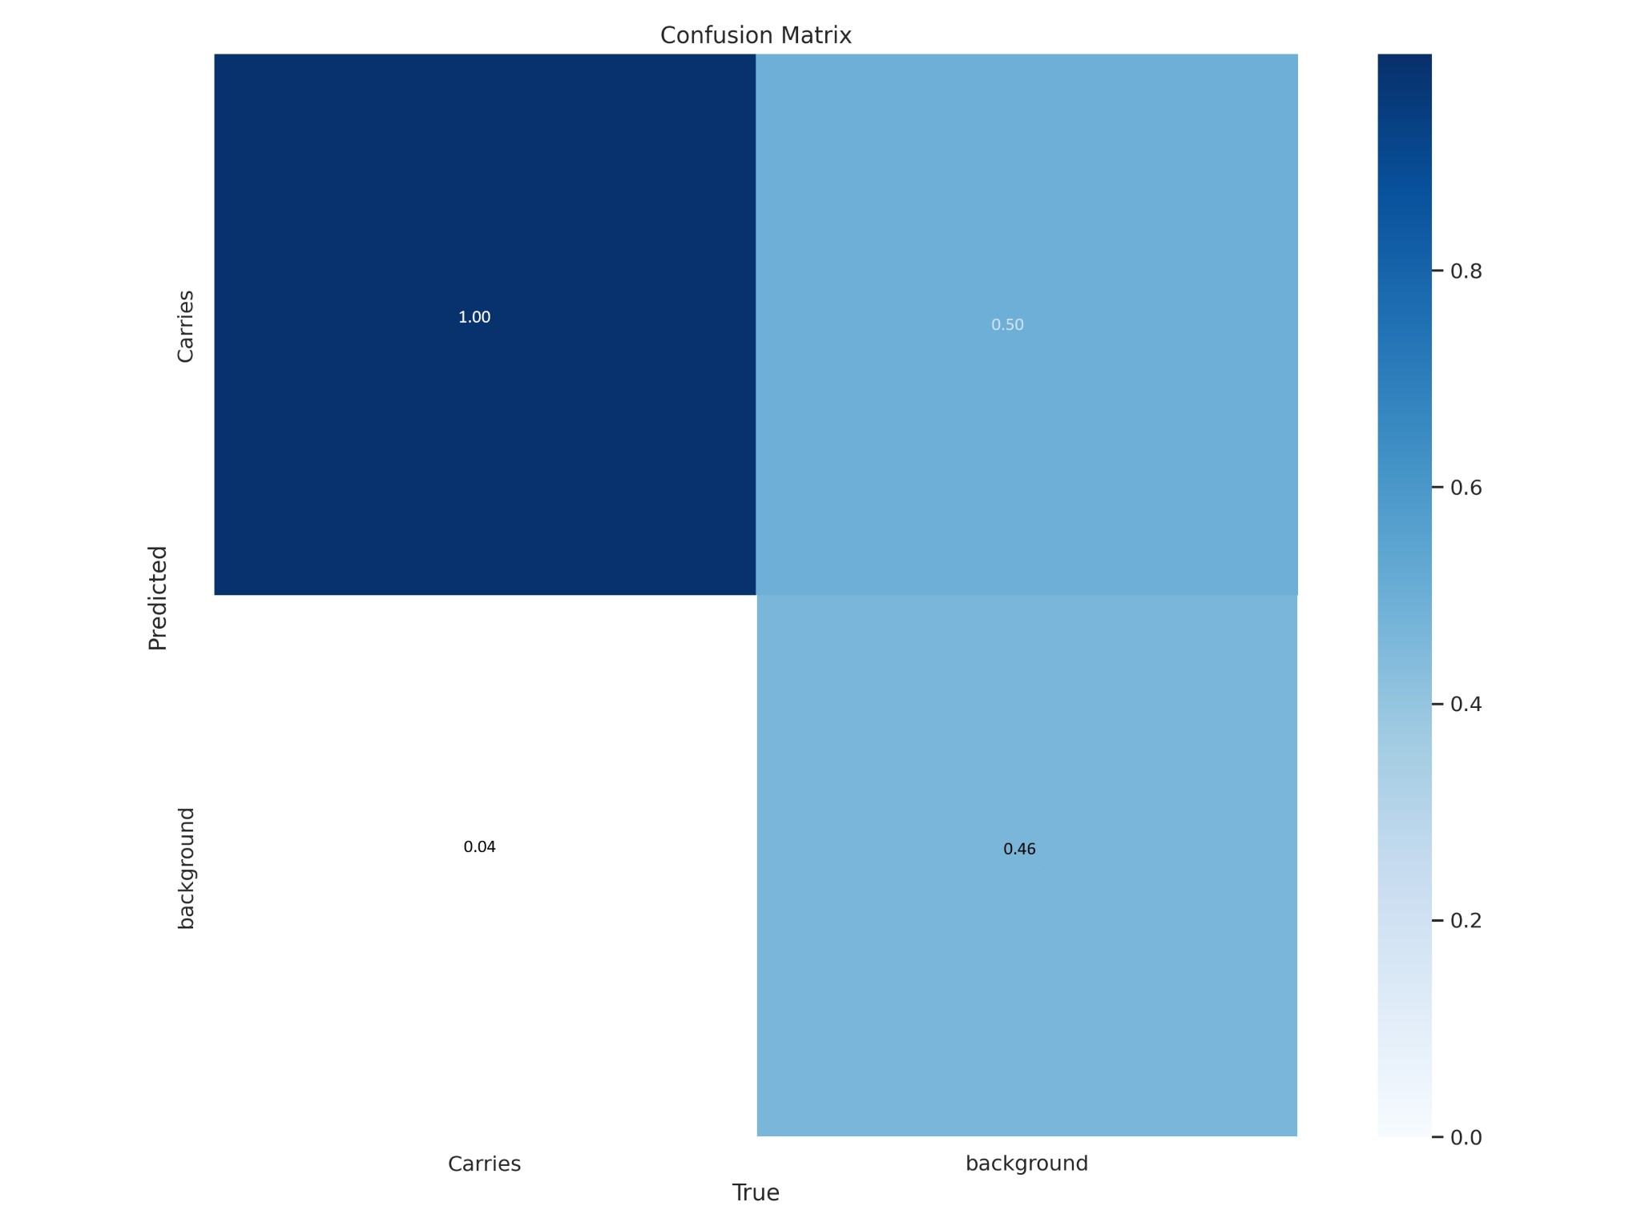

Figure 5.3: Confusion Matrix of raw images.

The Following Confusion Matrix is 2*2. There are two classes. One is Carries another one is Background. We can say Background is no carries class. So here is the following confusion matrix described: TP (True Positive) = 100 TN (True Negative) = 46 FP ( False Positive) = 54 FN (False Negative) = 4

A train/cls loss graph refers to a graph representing the classification (cls) loss during the training of a machine learning model. This loss is associated with the model’s ability to correctly classify input data into different classes.

The classification loss measures the disparity between the predicted class probabilities and the actual class labels in the training data. As the model learns from the training data, the goal is to minimize this loss, meaning that the predicted classes align more closely with the true labels. A decreasing trend in the graph indicates improving classification performance during training.

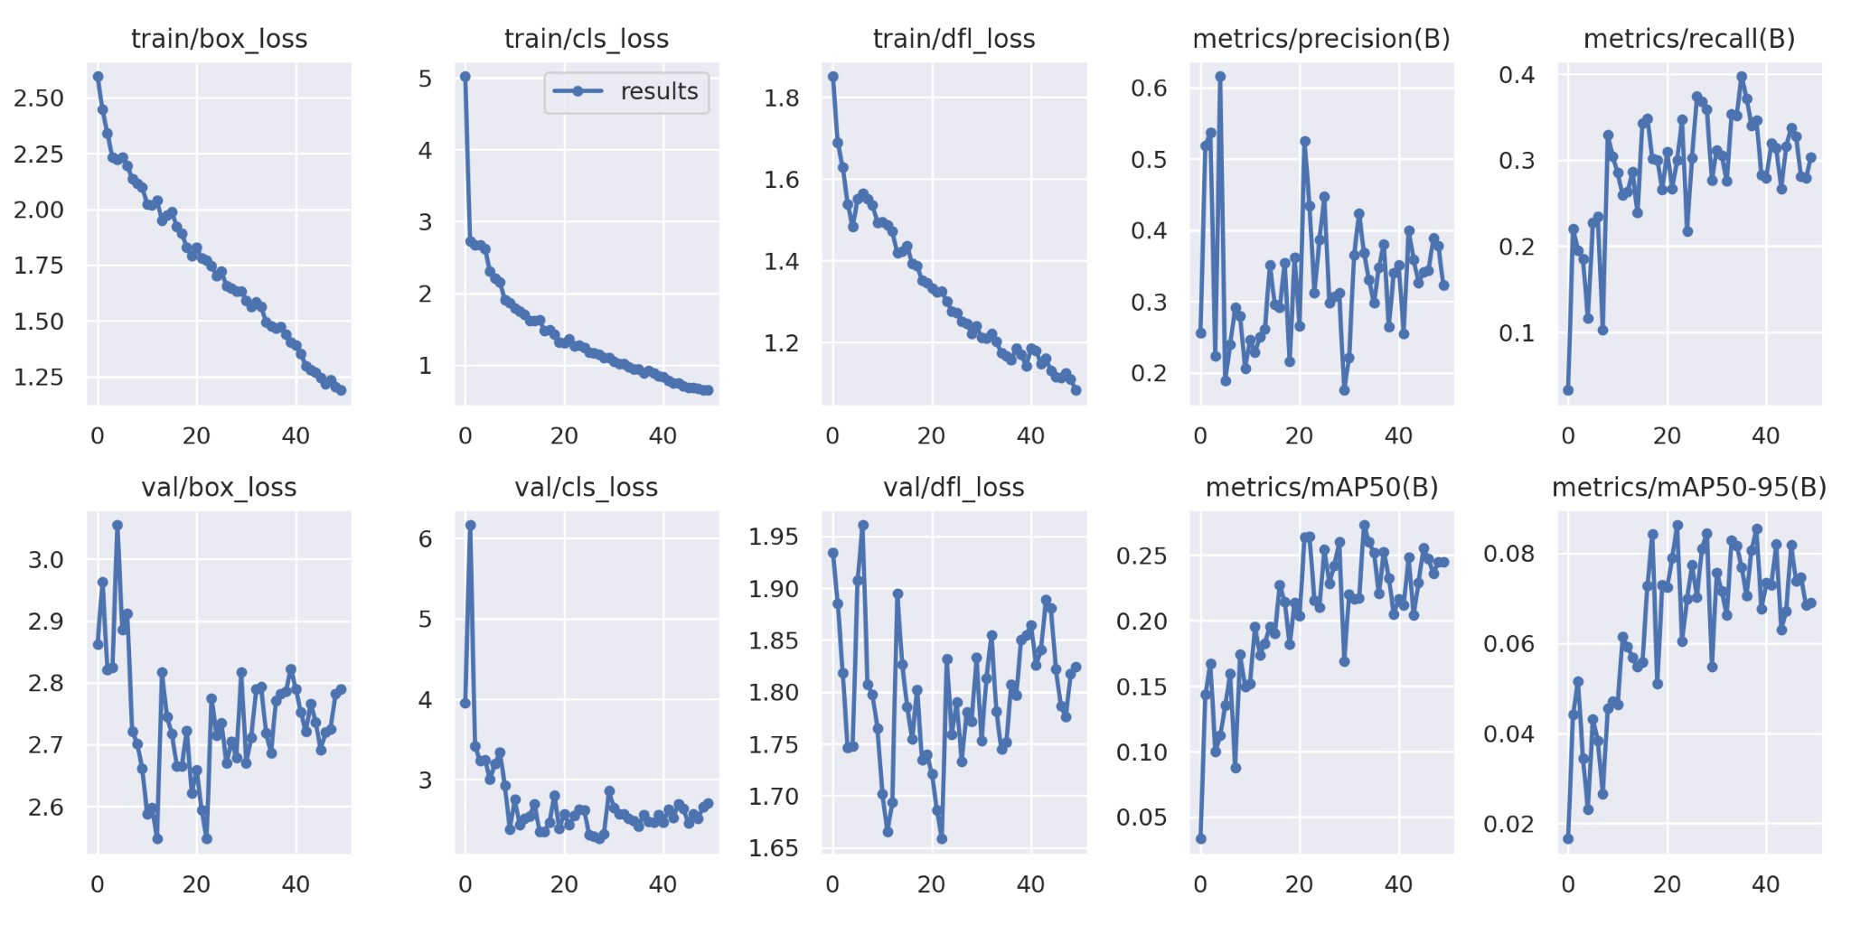

Figure 5.4: Result of yolov8

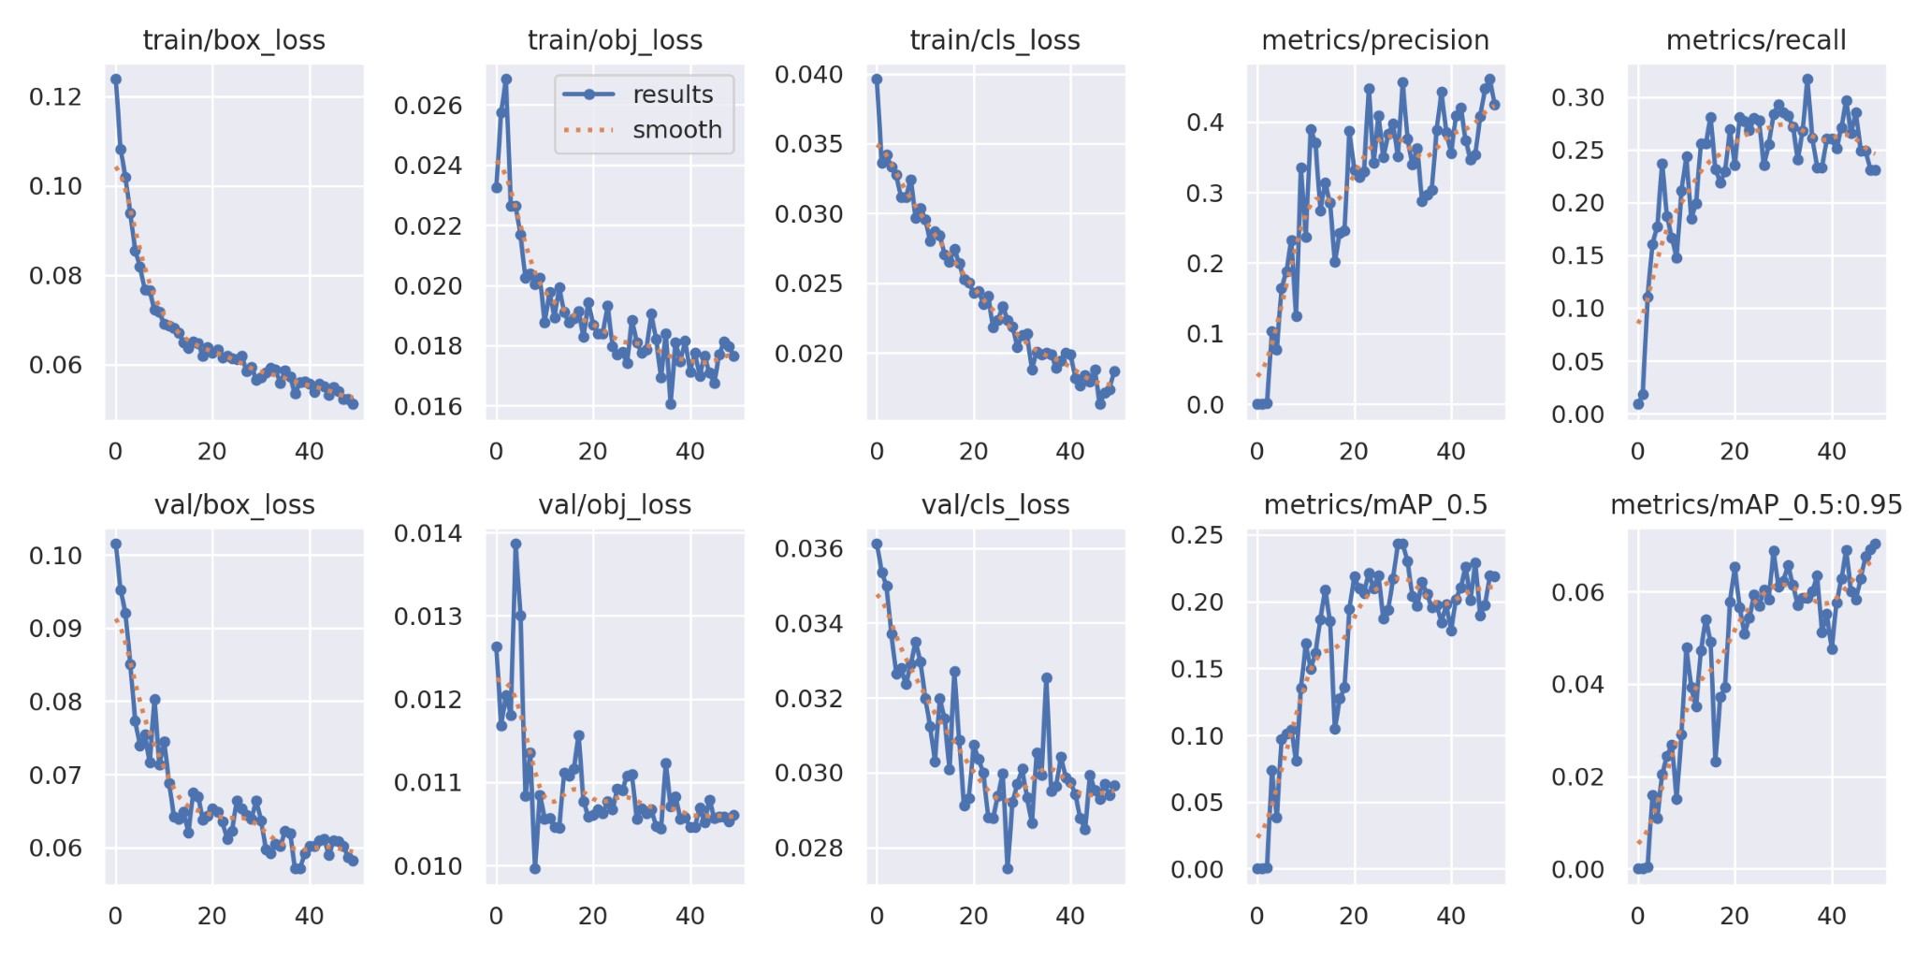

Figure 5.5: Result of yolov5

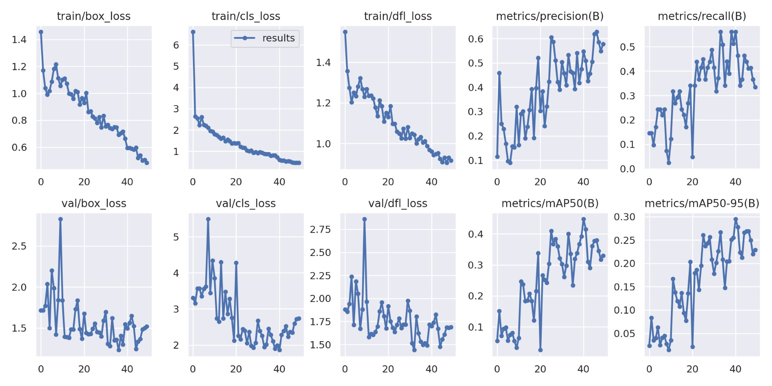

Figure 5.6: Result of yoloV8(Raw)

Chapter 6

Web Application

# 6.1 Software Development Method

In embarking on the development journey of a sophisticated dental caries detection system, we meticulously embraced an Agile methodology to ensure a dynamic and iterative approach to project management.

The initiation phase was marked by the formulation of a comprehensive vision statement that outlined the overarching goal of the system primarily, the early detection of dental caries for proactive and preventive dental care. Stakeholder identification played a pivotal role, ensuring the inclusion of perspectives from dentists, software developers, and end-users. Initial user stories were meticulously crafted to encapsulate the functional requirements from the user’s standpoint, laying the groundwork for subsequent development.

The sprint planning phase was characterized by rigorous backlog refinement, incorporating feedback from owner of the system and prioritizing features for upcoming sprints. Sprint goals were defined with precision, taking into consideration the project’s priorities and feasibility. Task breakdown involved granular dissection of user stories into smaller, manageable tasks, with detailed estimates of time and resources required for each.

Development sprints were conducted with a keen focus on iterative development, typically spanning 2-4 weeks. Regular progress reviews ensured that the project remained on track, with adjustments made as necessary. Continuous integration of new code was a fundamental practice to maintain a consistently functional system. Importantly, user feedback, especially from dentists, was actively sought at regular intervals to ensure that the detection algorithms aligned with the real-world nuances of dental practice.

Testing and quality assurance were paramount components of our agile approach. Automated testing frameworks were implemented to guarantee the reliability and accuracy of the detection algorithms. User acceptance testing at the conclusion of each sprint provided valuable insights, shaping the system based on real-world feedback.

Sprint reviews and retrospectives were integral components of our methodology. Sprint reviews involved showcasing completed features to stakeholders, fostering a collaborative environment for feedback collection. Retrospectives, in turn, facilitated a reflective examination of the sprint, identifying successes and areas for refinement. Adjustments to the development process were made based on these reflections.

The deployment and maintenance phase followed an incremental approach, releasing new features as they were completed and rigorously tested. Continuous monitoring tools were implemented to track the system’s performance, with ongoing support and updates provided to ensure system integrity. Continuous improvement was ingrained in our methodology. Feedback loops were established to continuously gather insights from users and stakeholders, informing iterative enhancements. Adaptability was a cornerstone, allowing the project to evolve in response to changing requirements and technological advancements. This agile approach facilitated the development of a robust dental caries detection system.

# 6.2 Deployment

The machine learning model will be implemented in a web application or mobile app that dentists and other healthcare professionals may use to detect dental caries and other dental problems in x-ray pictures.

In addition to the foregoing, the data analysis plan should include a summary of the study’s background. This includes things like:

* The study’s target audience
* The availability of data
* The study’s resources
* The study’s ethical considerations

While the proposed technique is primarily focused on quantitative data analysis, it is critical to examine the context and potential implications on the outcomes. Any unique features, such as differences in X-ray imaging procedures or the inclusion of varied patient populations, should be included in data analysis and interpretation. To provide a complete knowledge of the research context, the contextual elements relating to the dataset, including any potential limits or biases, should be thoroughly described.

# 6.3 Website

Our website can detect caries from both dental x ray images and raw images. So a user first saw a homepage then he can select any of the option either raw image or x ray image. User can input a image by a url or from the local device we have both the options. Then out system can detect if the image cantains any caries and which is the stage of the caries.

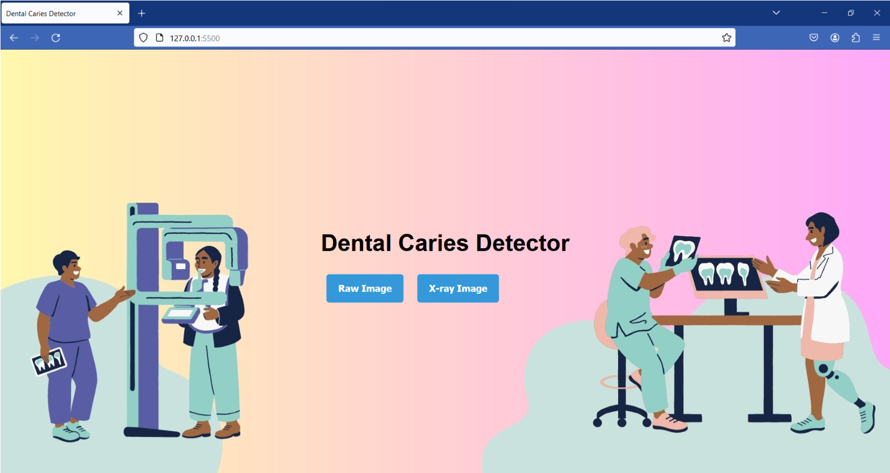

Figure 6.1: Home Page

In our website we have developed two kind of images that can be given. Number one is x-ray images and another one is the tooth picture you have taken by your device. In that website user will find two options. One is for raw image and another one is X-ray.

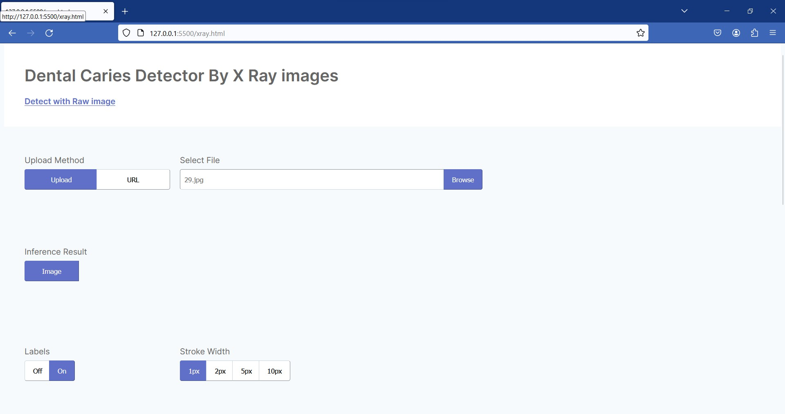

Figure 6.2: X-ray page

If someone has x-ray images they will click on X-ray images it will take them to another page. This page will be called dental carries detector by X-ray images. In the page user can upload their X-ray images from their device. They can select between levels on or off. It basically shows the levels on the images. Then clicking on run will show the stages in the X-ray images. While generating the image it will also give some suggestions advice according to the picture.

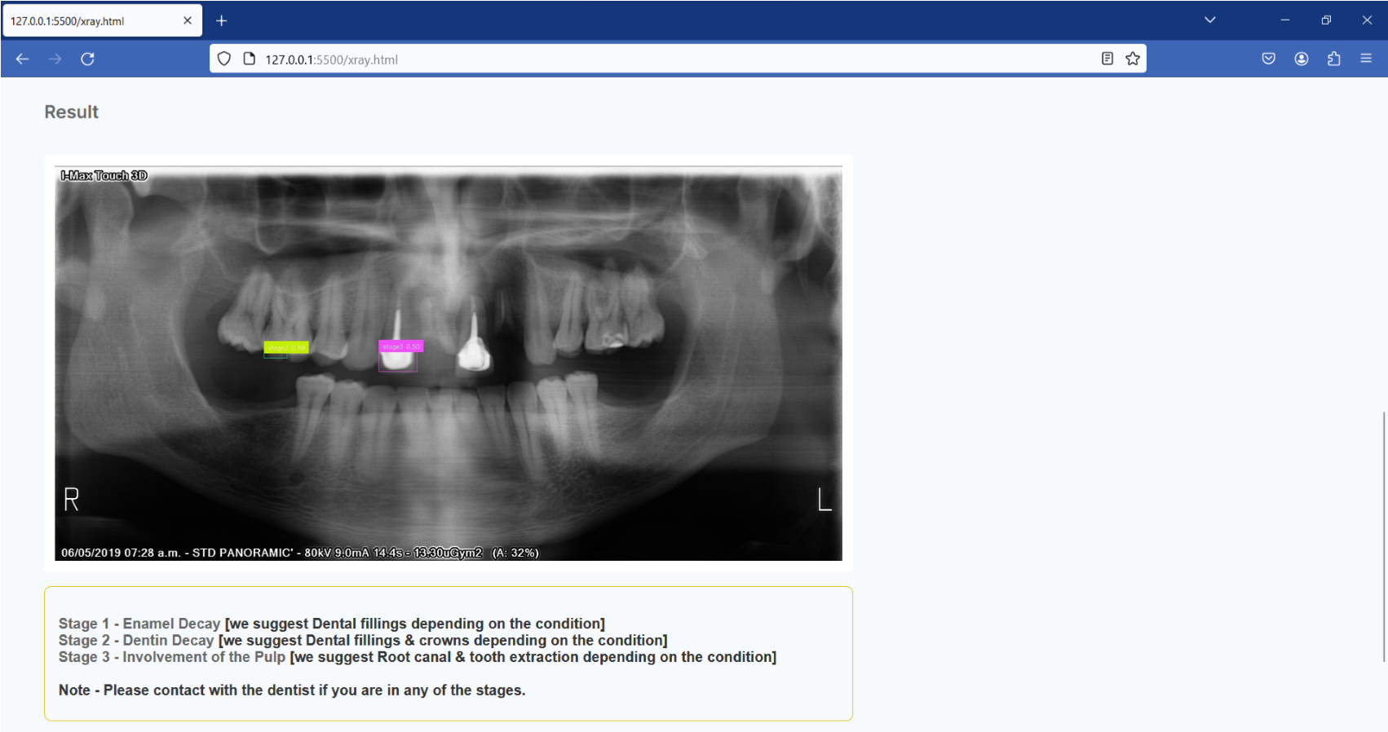

Figure 6.3: Output of the x-ray

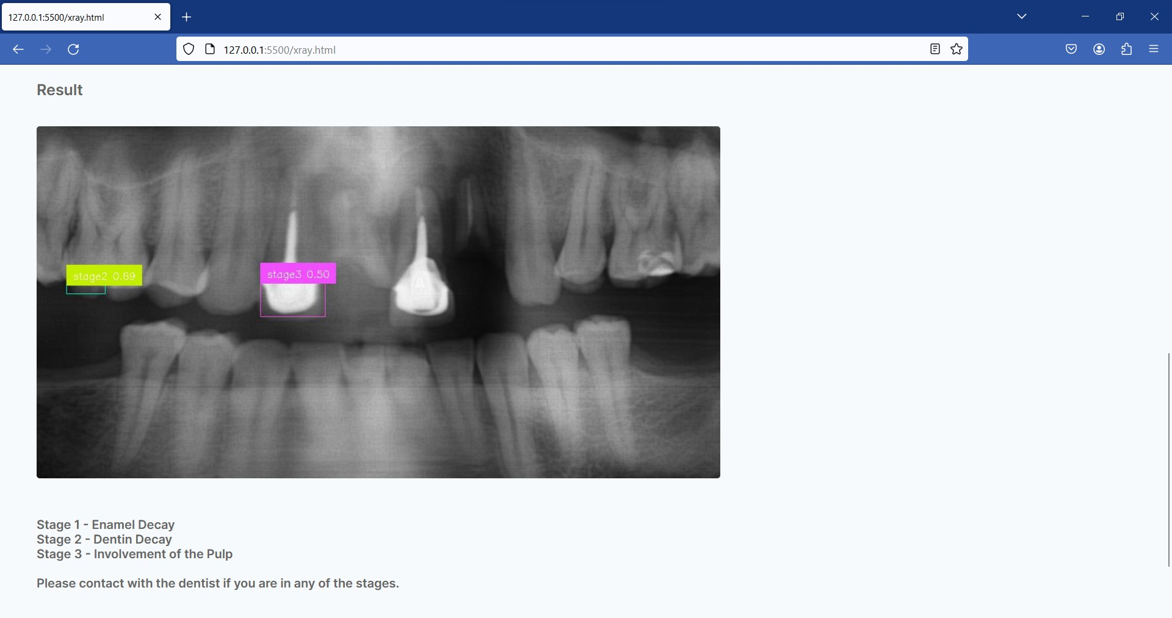

Figure 6.4: Zooming for details

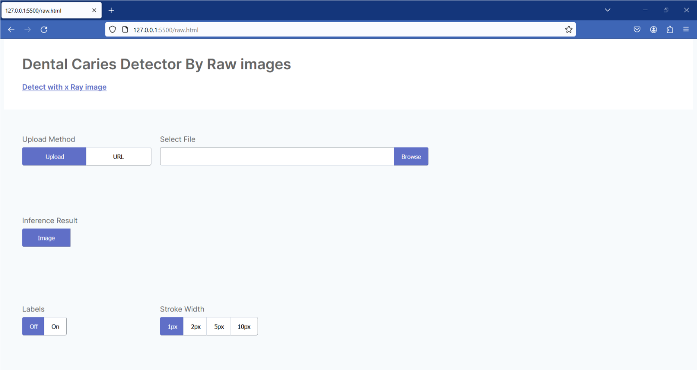

Figure 6.5: Raw Image Page

Another section is called raw image page in this page user will upload their pictures by taking in their phone or devices. After clicking on run it will show that predicted result.

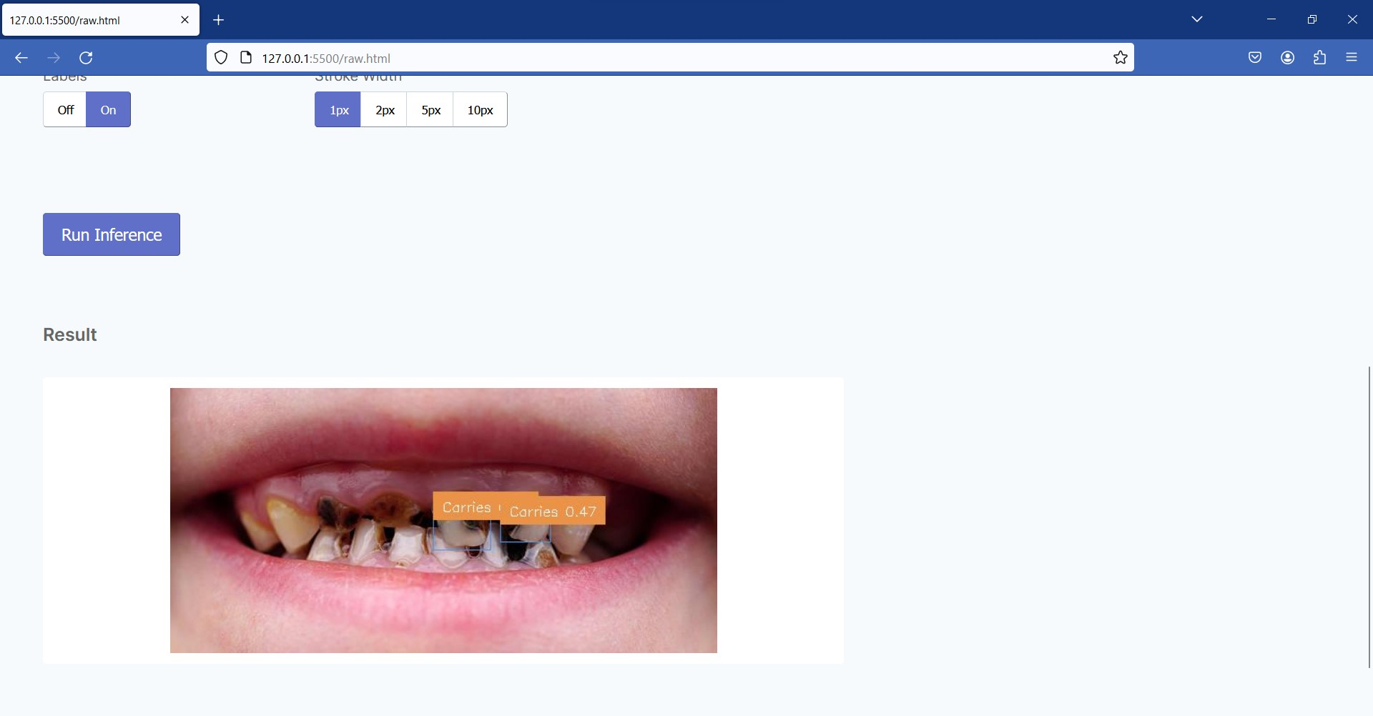

Figure 6.6: Output of the image

# 6.4 Business Model

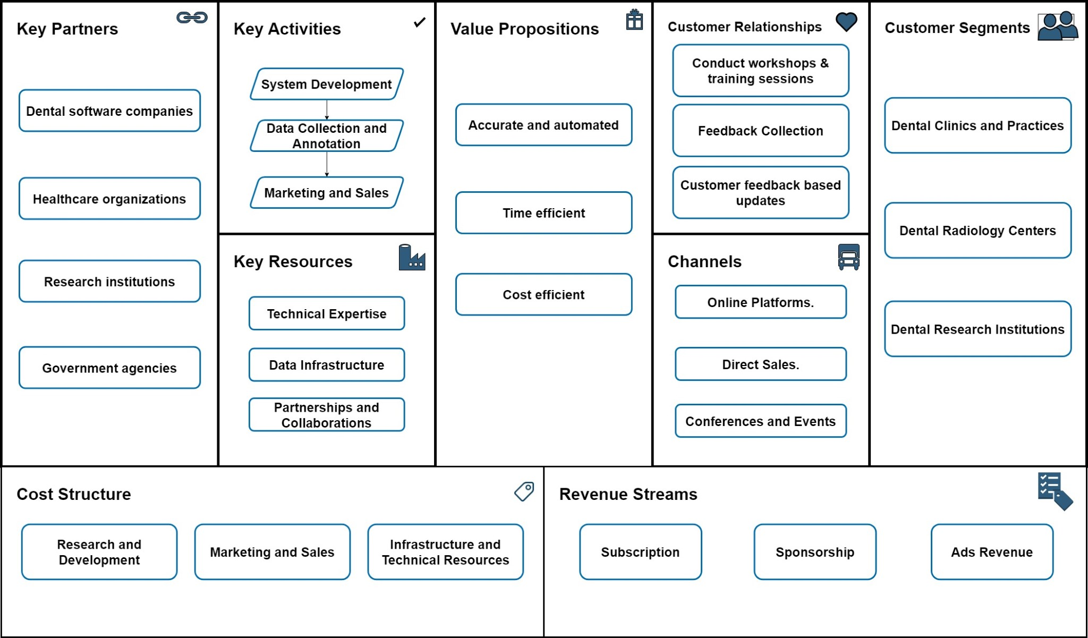

Figure 6.7: Business Model

1. Value Proposition:

Accurate Diagnostics: Utilize advanced computer vision and machine learning algorithms to provide a cutting-edge solution for the precise diagnosis of dental cavities and illnesses from X-ray pictures.

Diagnosis Efficiency: Provide a time-saving tool that supports dental professionals in making quick and accurate assessments, streamlining the diagnostic procedure.

Improved Patient Care: Help to improve patient care by allowing for the early detection and treatment of dental disorders.

1. Target Audience:

Dentists and dental clinics: Primary consumers looking for enhanced diagnostic technologies to increase diagnostic accuracy.

Dental Radiologists: Dental imaging specialists who can benefit from advanced diagnostic technology.

Dental Laboratories:Organizations that analyze and process dental X-ray pictures. 3. Revenue Streams:

Software Licensing: Charge dental clinics and professionals for licensing dental caries and disease detection software.

Subscription:Provide a subscription-based mechanism for ongoing access to software upgrades and support.

Training Services: Provide dental professionals with training programs on how to use the automated diagnostic instrument.

Maintenance and Support: Recurring fees might be charged for continuing maintenance, updates, and customer support

1. Key Activities:

Software Development:Continuous enhancement and development of diagnostic software based on the most recent advances in computer vision and machine learning.

Research and Development: Continued research efforts will keep you at the forefront of dental imaging and diagnostic technology.

Training Programs: Create and deliver training to dentistry professionals.

Customer Support: Provide prompt and effective customer service for softwarerelated issues.

1. Channels:

Online Platform: Create an easy-to-use online platform for acquiring and accessing diagnostic software.

Dental Conferences and Exhibitions: To reach out to potential clients, exhibit your technologies at dental industry events.

Collaborations: Work with dental equipment dealers and technology providers to broaden your market reach.

1. Cost Structure:

Software Development: Investing in the creation and upkeep of diagnostic software. Research and Development: Invest in continuing research to stay on the cutting edge of dental diagnostic technologies.

Marketing and Sales: Budget for digital marketing, attendance at industry events, and relationship development in marketing and sales.

Customer Service: Set aside resources to provide efficient and responsive customer service.

1. Key Partnerships:

Distributors of Dental Equipment: Work with distributors to integrate the diagnostic equipment into existing dental technology.

Dental Associations: Form alliances with dental associations to gain endorsement and a broader market reach.

Research Institutions:Collaboration with research institutions is essential for continued developments in dental diagnostic technology.

1. Customer Relationships:

Training Programs: Create and provide training programs to guarantee that the diagnostic instrument is used correctly.

Customer Service: Provide prompt customer service to address questions and concerns. Feedback Mechanism:Establish a feedback mechanism to gather insights for continual improvement.

1. Funding:

Initial finance: Seek finance for software development and market entry from private investors, venture capitalists, or government subsidies.

Collaborative Funding: Look into prospects for collaborative funding with dental technology businesses.

# 6.5 Cost Structure

## 6.5.1 COCOMO

To estimate the cost impact of using COCOMO to automate dental caries detection, we will follow the approach with the following factors:

Project Size (ESLOC): Estimate the size of the project in terms of Estimated Source Lines of Code (ESLOC). This will depend on the complexity and features of the caries detection system.

Project Complexity: Rate the complexity of the project on a scale of 1 to 5, with 5 being the most complex. The complexity rating will affect both development and maintenance costs.

Development Team Experience: Assess the experience of the development team. A more experienced team can develop and maintain the system more efficiently, potentially reducing costs.

Here is a cost analysis calculation for automating dental caries detection using CO-

COMO:

Project size: 10,000 ESLOC

Project complexity: 3

Development team experience: Experienced COCOMO cost estimation model:

The COCOMO cost estimation model is a mathematical model that can be used to estimate the cost of developing a software project. The model considers the size and complexity of the project, as well as the experience of the development team. The following formula can be used to calculate the cost of a software project using COCOMO:

*Cost* = *K* ∗ *E* ∗(*ESLOC*)*F*

where:

* K is a constant that depends on the development team experience
* E is a constant that depends on the project complexity
* ESLOC is the estimated source lines of code • F is a constant that depends on the project complexity Sample calculation:

Using the following values:

* K = 3
* E = 3
* ESLOC = 10,000
* F = 1.12

The cost of the project can be calculated as follows:

Cost = 3×3×(10*,*000)1*.*12 = 567*,*861 ≈ 600*,*000

We assume that we need 5 months for the project and 4 employees work in the project.

Junior Developer (x2): 30,000 per month

UI/UX Designer (x2): 35,000 per month

Total Monthly Salary Cost:

230*,*000+215*,*000 = 90000 Total Salary Cost for 5 months: 590*,*000 = 4*,*50*,*000

Other Costs: Look for more cost-effective software/tools licenses.

Explore affordable hosting solutions.

Revised Other Costs:

Software/Tools Licenses: 30,000

Server Hosting: 80,000

Miscellaneous Expenses: 15,000

Total Other Costs: 30*,*000+80*,*000+15*,*000 = 1*,*25*,*000

Total Estimated Budget : 4*,*50*,*000+1*,*25*,*000 = 5*,*75*,*000

This is the estimated budget to run this system.

# 6.6 Meetings Schedule with Agenda

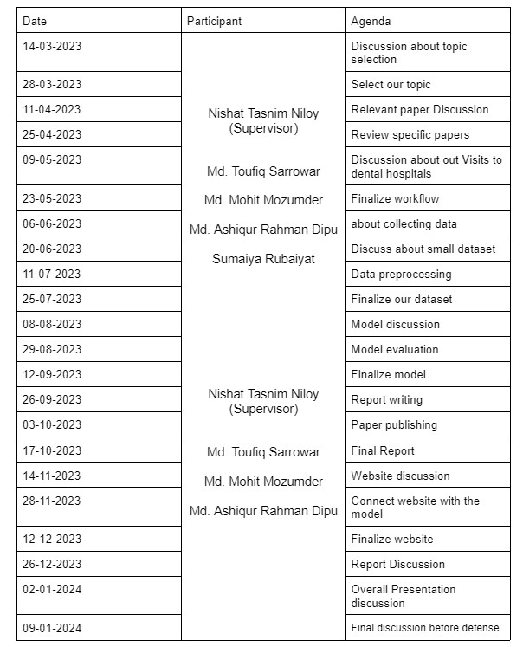

We have conducted several meetings both online and offline to effectively develop our project. We also communicated with our respected supervisor for his valuable advice and direction. All the team members contributed their best to build this project. Everyone was active and fulfilled their part immensely.

# 6.7 Contributions

It was a team project, so everyone contributed their part perfectly. To develop this project, a wide range of analysis, programming experience, machine learning, and deep learning knowledge was required. So, all the team members contributed as per their capability to complete the project. It is very necessary to communicate effectively to get a good output. We have worked together and valued each other’s opinions while developing this project.

Capstone A

|  |  |
| --- | --- |
| Name | Contribution |
| Md. Mohit Mozumder | Literature review, abstract, background study, limitations, ethical considerations, documentation by LaTeX |
| Md. Toufiq Sarrowar | Literature review, introduction, business model, expected result, conclusion, documentation by LaTeX |
| Md.Ashiqur Rahman Dipu | Literature review, planning and methodology, dataset description, proposed model, technology materials, documentation by LaTeX |
| Sumaiya Rubaiyat | Literature review, objective, research question, Report writing, flowchart |

Table 6.1: Contributions of Team Members

Capstone B

|  |  |
| --- | --- |
| Name | Contribution |
| Md. Mohit Mozumder | Literature review, abstract, Background Study, flowchart, limitations, Ethical Considerations, Model selection,Collaborating with the Dentists, Data collection and preprocessing, train Yolo v8, Documentation by latex. |
| Md. Toufiq Sarrowar | Literature review, Introduction,business model, Conclusion, Model selection, Collaborating with the Dentists, Data collection and Data preprocessing, Train v5, Train Unet, Documentation by latex. |
| Md.Ashiqur Rahman Dipu | Literature review, Planning and methodology ,dataset description, proposed model, technology materials,Collaborating with the Dentists, Data collection and Data preprocessing, Performance evaluation, result analysis, Documentation by latex |
| Sumaiya Rubaiyat | Literature review, Objective, research question, Collaborating with the Dentists, Data collection, Dentistry as a whole,Data analysis in Dentistry, Integration of Technology |

Table 6.2: Contributions of Team Members

Capstone C

|  |  |
| --- | --- |
| Name | Contribution |
| Md. Mohit Mozumder | Literature review, abstract, Background Study, flowchart, limitations, Ethical Considerations, Model selection, Data collection and preprocessing,model architecture, train Yolo v8, Website Creating and deploying. |
| Md. Toufiq Sarrowar | Literature review, Introduction,business model, Conclusion, Model selection, Data collection and Data preprocessing, model architecture,Train v5, Train Unet, Website Creating and deploying. |
| Md.Ashiqur Rahman Dipu | Literature review, Planning and methodology ,dataset description, proposed model, technology materials, Data collection and Data preprocessing, Performance evaluation, result analysis, limitation of future works. |
| Sumaiya Rubaiyat | Literature review, Objective, research question, Data collection,model architecture, Problem statement, overall conclusion, Report writing, Collaborating with the Dentists, Data collection, Dentistry as a whole,Data analysis in Dentistry,Integration of Technology such as RoboFlow. |

Table 6.3: Contributions of Team Members

Chapter 7 Conclusion

# 7.1 Overall Conclusion

The creation of a dental caries and disease detection system has important ramifications for the field of dentistry and oral healthcare. Dental professionals can speed up their diag noses and enhance patient outcomes by providing a dependable and automated diagnostic tool. Furthermore, the ability to distinguish between various types of dental caries and illnesses helps lead specific treatment programs and improve patient care.

Despite these challenges, I believe this research has the potential to have a big impact on the area of dentistry. We hope to establish an accurate and efficient dental caries and disease detection system that may assist dental practitioners in their diagnosis and enhance overall oral healthcare by following this proposed methodology and employing CNNs as the method of choice. The findings of this study will highlight the promise of computer vision and machine learning approaches for dental diagnostics, while also taking into account their affordability and practicality for use in real-world dental clinics. Finally, successful application of this approach in dental clinics can lead to improved diagnostic accuracy, lower treatment costs, and overall improvements in oral health care.

# 7.2 Limitation and Future Works

Dental caries detection systems face challenges in sensitivity and specificity, requiring research to enhance accuracy and reduce false positives and negatives.

* Image quality dependency hampers performance. Future work should focus on methods to ensure robustness to variations in image conditions.
* Addressing the struggle to detect early lesions is crucial for timely intervention and minimally invasive treatments.
* Seamless integration into clinical workflows is essential for widespread adoption, necessitating user-friendly solutions for dental practitioners.
* Personalized risk assessment models, incorporating diverse data sources, can improve accuracy by considering individual factors influencing caries development.
* Increasing machine learning explainability and developing continuous monitoring systems aid in building trust, facilitating collaboration between clinicians and AI for early detection and intervention in oral health.

References

1. Abdulaziz A Al Kheraif, Ashraf A Wahba, and H Fouad. Detection of dental diseases from radiographic 2d dental image using hybrid graph-cut technique and convolutional neural network. *Measurement*, 146:333–342, 2019.
2. Pouya Amrollahi, Brinda Shah, Amir Seifi, and Lobat Tayebi. Recent advancements in regenerative dentistry: A review. *Materials Science and Engineering: C*, 69:1383–1390, 2016.
3. Eugenio D Beltrán-Aguilar, Laurie K Barker, María Teresa Canto, Bruce A Dye, Barbara F Gooch, Susan O Griffin, Jeffrey Hyman, Freder Jaramillo, Albert Kingman, Ruth Nowjack-Raymer, et al. Surveillance for dental caries, dental sealants, tooth retention, edentulism, and enamel fluorosis–united states, 1988-1994 and 1999-2002. 2005.
4. John DB Featherstone. The science and practice of caries prevention. *The Journal of the American dental association*, 131(7):887–899, 2000.
5. Ozlem Gormez and Hasan Huseyin Yilmaz. Image post-processing in dental practice. *European Journal of Dentistry*, 3(04):343–347, 2009.
6. Jae-Hong Lee, Do-Hyung Kim, Seong-Nyum Jeong, and Seong-Ho Choi. Detection and diagnosis of dental caries using a deep learning-based convolutional neural network algorithm. *Journal of dentistry*, 77:106–111, 2018.
7. Shinae Lee, Sang-il Oh, Junik Jo, Sumi Kang, Yooseok Shin, and Jeong-won Park. Deep learning for early dental caries detection in bitewing radiographs. *Scientific reports*, 11(1):16807, 2021.
8. TM Lehmann, E Troeltsch, and K Spitzer. Image processing and enhancement provided by commercial dental software programs. *Dentomaxillofacial Radiology*, 31(4):264–272, 2002.
9. Luya Lian, Tianer Zhu, Fudong Zhu, and Haihua Zhu. Deep learning for caries detection and classification. *Diagnostics*, 11(9):1672, 2021.
10. Matthew J McAuliffe, Francois M Lalonde, Delia McGarry, William Gandler, Karl Csaky, and Benes L Trus. Medical image processing, analysis and visualization in clinical research. In *Proceedings 14th IEEE Symposium on Computer-Based Medical Systems. CBMS 2001*, pages 381–386. IEEE, 2001.
11. André Mol. Image processing tools for dental applications. *Dental clinics of North America*, 44(2):299–318, 2000.
12. Mircea Paul Muresan, Andrei Razvan˘ Barbura, and Sergiu Nedevschi. Teeth detection and dental problem classification in panoramic x-ray images using deep learning and image processing techniques. In *2020 IEEE 16th International Conference on Intelligent Computer Communication and Processing (ICCP)*, pages 457–463. IEEE, 2020.
13. Kyeong-Jin Park and Keun-Chang Kwak. A trends analysis of dental image processing. In *2019 17th international conference on ICT and knowledge engineering (ICT&KE)*, pages 1–5. IEEE, 2019.
14. Ruben Pauwels. A brief introduction to concepts and applications of artificial intelligence in dental imaging. *Oral radiology*, 37(1):153–160, 2021.
15. María Prados-Privado, Javier García Villalón, Carlos Hugo Martínez-Martínez, Carlos Ivorra, and Juan Carlos Prados-Frutos. Dental caries diagnosis and detection using neural networks: a systematic review. *Journal of clinical medicine*, 9(11):3579 , 2020.
16. Shreyansh A Prajapati, R Nagaraj, and Suman Mitra. Classification of dental diseases using cnn and transfer learning. In *2017 5th International Symposium on Computational and Business Intelligence (ISCBI)*, pages 70–74. IEEE, 2017.
17. Hanifah Rahmi-Fajrin, Sartika Puspita, Slamet Riyadi, and Erma Sofiani. Dental radiography image enhancement for treatment evaluation through digital image processing. *Journal of clinical and experimental dentistry*, 10(7):e629, 2018.
18. Muhammad Imran Razzak, Saeeda Naz, and Ahmad Zaib. Deep learning for medical image processing: Overview, challenges and the future. *Classification in BioApps: Automation of Decision Making*, pages 323–350, 2018.
19. Ingrid Scholl, Til Aach, Thomas M Deserno, and Torsten Kuhlen. Challenges of medical image processing. *Computer science-Research and development*, 26:5–13 , 2011.
20. Gil Silva, Luciano Oliveira, and Matheus Pithon. Automatic segmenting teeth in xray images: Trends, a novel data set, benchmarking and future perspectives. *Expert Systems with Applications*, 107:15–31, 2018.
21. Bart Vandenberghe, Reinhilde Jacobs, and Hilde Bosmans. Modern dental imaging: a review of the current technology and clinical applications in dental practice. *European radiology*, 20:2637–2655, 2010.
22. Jie Yang, Yuchen Xie, Lin Liu, Bin Xia, Zhanqiang Cao, and Chuanbin Guo. Automated dental image analysis by deep learning on small dataset. In *2018 IEEE 42 nd annual computer software and applications conference (COMPSAC)*, volume 1 , pages 492–497. IEEE, 2018.

Appendix